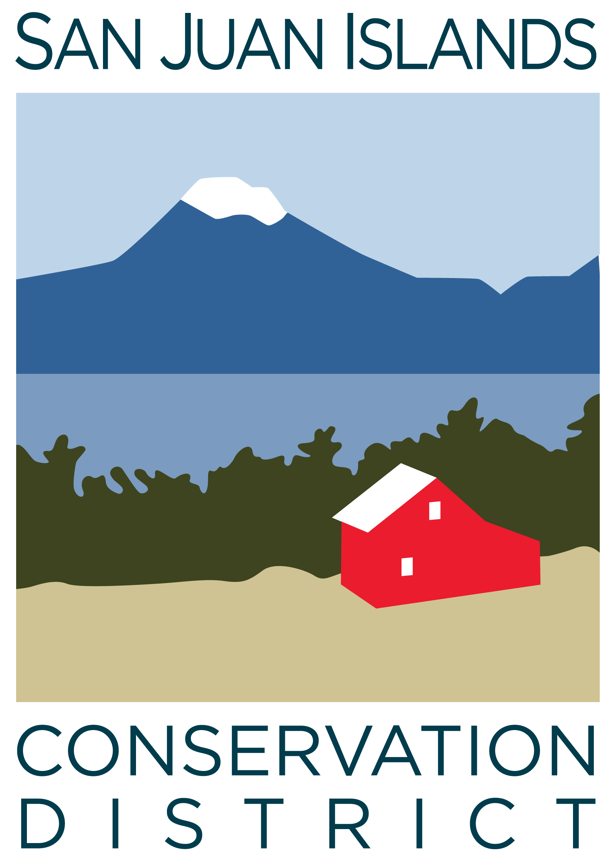
San Juan Islands Conservation District
BOARD OF SUPERVISORS
REGULAR MEETING MINUTES

Date: | May 24, 2024
Time: | 9:00am – 11:00am
Place: | 915 Spring St. Friday Harbor, WA 98250  And online via Zoom
Attending Supervisors: | Carson Sprenger, David Bill, Claire Crawbuck, Lynn Bahrych
Attending Associates:
Absent: | Vicki Heater, Jim Skoog
Partners: | Kathy Smith, NRCS; Jean Fike, WSCC Puget Sound Regional Manager; David Vliet and Alan Chapman, WACD NW Region Representatives
Staff: | Paul Andersson, Tony Fyrqvist, Kai Hoffman Krull, Patricia Peterson
Public:

 | Welcome and Introductions
 | Introduction of WACD NW Region Representative Davie Vliet and SJICD new employee Patricia Peterson.
1 | Agenda Approval
 | Action Item: Lynn made a motion to approve the Agenda with an addition of a new Action Item under 5. New Business stating: “Approve contracts and payments to Rainshadow Consulting and to Carson Sprenger”. The motion was seconded by David and passed.
2 | April 2024 Regular Meeting Minutes Approval
 | Action Item: David made a motion to approve the Minutes from the 4/26/24 Regular Meeting. Lynn provided the second and the motion passed.
3 | Financial Report – April Financials
Action Item: Motion was made by Lynn and seconded by David to approve the April 2024 financial documents, including:
- Balance Sheet
- Statement of Revenues and Expenses
- Credit Card Details
- Bank Reconciliation
- Adjusting Journal Entries
- Payroll
Discussion included:
- Review of the Financial Summary Report.
- Emphasis was placed on the purchase of 915 Spring St office building for District Conservation Campus. The transaction closed on 4/25/24 with a purchase price of $880,000 funded by a loan from USDA Rural Development of $870,000 with 3.50% fixed rate for 35 years resulting in a monthly payment of $3,602.
- Funding of the purchase related costs was from the operating account, not from the reserve account.
- Separate restricted savings account was established to be in compliance with the loan covenant requiring a monthly credit of 10% of the payment amount until the balance reaches $43,224.
- Monthly revenue levels continue to be higher than during the previous year.
- Recovery of large payments made for District programs continues as projected from invoicing, with corresponding increases in the operating account balance.
The motion passed.
 | Discussed grant pipeline report including the large grants being processed for the Paul G Allen Foundation. The District did not receive NOAA Workforce Training for $450,000, but will be applying again during the next round. The District also did not receive the Archives File Cleanup Grant for $5,700 due to the high number of applications. YCC is exploring ways to raise additional revenue.
4 | Old Business
Action Item: Discussion and Motion to approve FY 2025 SJICD Annual Work Plan. David made a motion to approve the Annual Work Plan with Lynn providing the 2nd. The discussion included:
- Growth in District budget from $1,614,400 for FYE 6/30/24 to $2,648,000 at FYE 6/30/25.
- Increase in staffing to 16 employees.
- With increase in Commission funding with 25% indirect the District is able to build cash reserves to accommodate growth.
Discussion Item: Property transition.
Currently the District has leases with 2 tenants who will start making lease payments in June:
- San Juan County Emergency Management.
- Food Hub.
- The District has engaged interior designers from Orcas Island to present ideas regarding furniture, lighting, rugs, planters, benches, bookshelves and a library concept for the central area.
- Discussed art and ICC classroom.
- All operationally essential large items and computer systems were moved on 5/20/24. The remaining large items will be moved by the moving company on June 3rd , with staff continuing to move smaller items during the remainder of the month.
5 | New Business
Action Item – Discussion and motion to accept WSCC Riparian Grant and Sustainable Farms and Fields grants: Lynn made a motion to accept the grant packages and David provided the second.
- Riparian 24-03-RGP for $264,000 and $118,593.75 totaling $382,593.75
- Sustainable Farms and Fields 24-03-SF1 for $62,500 and $7,000 totaling $69,500.
The motion passed.
 | Action Item – Discussion and motion to approve SJICD E-Signature Policy. David made a motion, seconded by Claire, to approve the E-Signature Policy which will be incorporated into the District Governance Policy under VIII. The motion passed.
 | Action Item – Resolution to establish DRS Deferred Compensation Program.
 | Action Item – Approve Contracts and Payments to Rainbow Consulting and to Carson Sprenger. In order to ratify prior approval and to enhance transparency as to the compliance with the District Supervisor Conflict of Interest Policy Lynn made a motion, seconded by David, to approve contracts and payments to Rainbow Consulting and to Carson Sprenger. The motion was amended to state that all amounts are to stay within the dollar limits specified in the applicable policy. The motion passed with Carson abstaining from voting.
6 | Staff and Program Reports
The May 2024 Staff and Program Reports provide a comprehensive outline of District activities. Comments included:
- VSP administration presentations to other districts, counties, and partner agencies.
- Increase in cost share activity.
- Wildfire Ready Neighbors Program has over 130 signups for home visits.
- ICC recently received $85,000 in DNR funding for fuel reduction.
- YCC is staffed with crew leaders and is at full capacity for crew members.
- Manager of the Eelgrass program is working on his Master Diver Certificate.
- Island Marble Butterfly activity has been observed at 2 new plots: Frazer II and Eagle Cove.
- The success of the new quarterly emailed newsletter was highlighted.
Kai Hoffman-Krull from ICC provided the staff presentation commencing with explanation of the organizational structure of the College of the Environment at Western Washington University which is divided into 4 departments:
- Environmental Studies
- Environmental Sciences
- Urban & Environmental Planning & Policy
- Salish Sea Region
Initially the ICC program was under Environmental Studies. But due to their interest in not being involved with remote programs ICC will be affiliated with the Urban & Environmental Planning & Policy department with practically no changes in the required coursework.
A presentation about the Salish Guardians Program focused on:
- First Nations Guardians Network in Canada has an agreement to manage 150 million acres.
- Guardians Network in Canada growing from 30 participating tribes to 100.
- Indigenous landscape initiative and datacentric approach to management by indigenous youth.
- Landscape management leading to improved forest health.
- Implementation of Indigenous Rangers Program which was originally developed in Australia to protect and manage their land, sea and culture through a combination of traditional knowledge with Western science and conservation practices.
- Indigenous Leadership Initiative implemented in the U.S.
- Maximize “data sovereignty” as a driving force of land management.
- Development of co-management agreements between the tribes and federal government regarding terrestrial access - similar to the existing management of fishery resources.
- Tribal management of landscape within the changing climate.
- Further development of Lummi program (similar to ICC). While the curriculum is in place, there is a need to investigate further a funding base to purchase equipment and a vessel and to develop further collaboration, and explore long-term partnership with ICC on various projects.
Riparian Restoration Program – FY24 Projects Slideshow of:
- Review of program
- Upcoming Projects: Planning/Design, Implementation, Maintenance/Monitoring.
7 | Subcommittees
 | Did not meet.
8 | Upcoming Trainings/Webinars/Events
Discussion Item: Ag Org Retreat May 30, 8:30am-2pm, Brickworks SJI
The County was provided with:
- Topics: San Juan County Food Systems Plan & Ag Viability Survey
- Participants include Ag Guild, Food Coop, Food Hub, Planners.
- Issues regarding open space/forest land designations and taxation which the County Planning Department does not currently have the capacity to process.
 | Discussion Item: WADE conference June 10-12 will be attended by Carson, Walt and Cathi and lodging arrangements have been made.
9 | Partner Reports
David Vliet - He is the WACD Northwest Area Director from Kitsap Conservation District:
- Currently WACD has 81-91 open resolutions which need to be prioritized as they are handled only by 3 person staff. They need to be prioritized and followed up by the Districts to assure appropriate attention.
- SJICD currently has an active Biochar in Livestock Feed resolution at WACD.
- To be sponsored as a bill the District need to contact the appropriate legislators – Senator Liz Lovett from the 40th Legislative District was named as a contact as she recently visited San Juan County and met with a District Supervisor.
Jean Fike – The topics in the most recent Commission business and strategic planning meeting covered:
- Certification of election results – election of Claire Crawbuck and appointment of Vicki Heater as Supervisors.
- Year-end funding.

Alan Chapman – He summarized the previous WACD board meeting including:
- Budget proposal
- Appointment of a Plant Material Center (PMC) board member
- Concerns by some districts regarding PMC profit transfer.
- Concerns about PMC meeting basic needs of Conservation Districts.
- WACD is hosting a Spring Legislative Workshop in Ellensburg or via Zoom from 5/29 – 5/30 with the agenda, which is posted on the website, covering resolution status, sustainable funding, committee updates, rates and charges, elections and strategic visioning.

 | Public Comments
 | None.
11 | Idea Pot
The following ideas were brought up by Supervisors:
- Construction of a kiln in shape of a “Wood Dragon” to turn woody debris to biochar and electricity with a long-term objective of conserving soil, as only a limited amount of topsoil remains on the earth.
- Expansion of offering ICC chainsaw training to the general public.
- Staging a grand opening of the new facility to the community later in the summer.

12 | Adjournment 11:00am
Next Meeting: |  | Regular Meeting - Friday, June 28, 2024, from 9:00am to 11:00am

