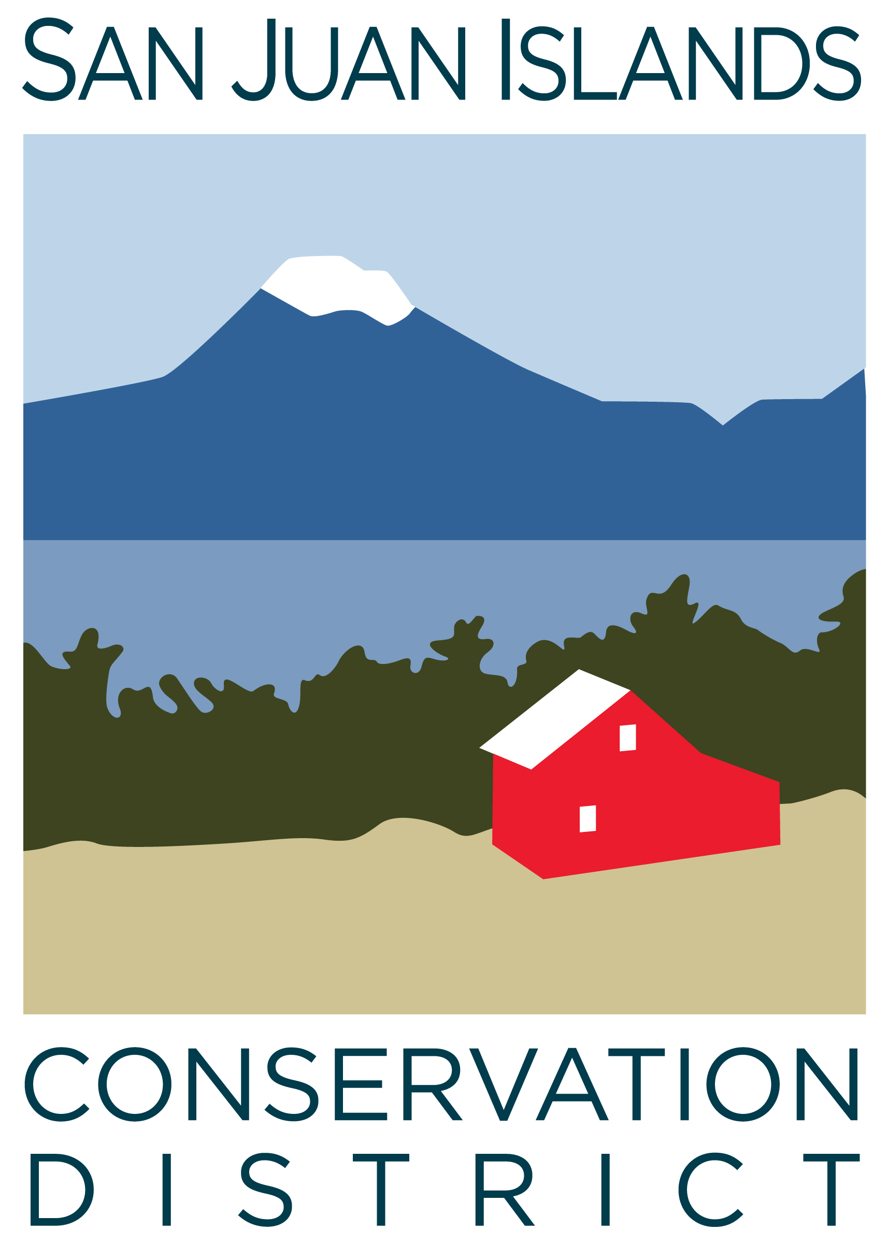
San Juan Islands Conservation District
BOARD OF SUPERVISORS
REGULAR MEETING MINUTES

Date: | January 26, 2024
Time: | 8:30am – 10:30am
Place: | 530 Guard Street, Friday Harbor, WA 98250  And online via Zoom
Attending Supervisors: | Carson Sprenger, David Bill, Vicki Heater, Lynn Bahrych
Attending Associates:
Absent: | Claire Crawbuck, Jim Skoog
Partners: | Kathryn Smith, NRCS; Alan Chapman, WACD; Koni Reynolds, USDA; Cathleen Walker, USDA; Jason Reyna, USDA
Staff: | Paul Andersson, Tony Fyrqvist
Public: | Andrew Jones

1 | Agenda Approval
 | Action Item: Motion to approve the Agenda was made by David, seconded by Lynn. Added motion to approve Candidate Statement Policy under (5) New Business. The motion passed.
2 | December 2023 Regular Meeting Minutes Approval
 | Action Item: Motion to approve the December 2023 meeting minutes was made by Vicki and seconded by David. The motion passed.
3 | Financial Officers Report – December Financials
Action Item: Motion was made by David and seconded by Lynn to approve the December 2023 financial documents, including:
- Balance Sheet
- Statement of Revenues and Expenses
- Credit Card Details
- Bank Reconciliation
- Adjusting Journal Entries
- Payroll
Discussion included:
- Financial Manager’s comments which were also provided in the SJICD Financial Summary.
- Youth Conservation Corps (YCC) historical financial statements and projections.
The motion passed.
Topic : Pipeline Report
- Discussed current and future applications for multiple new grants
5 | New Business – It was decided to discuss New Business (5) prior to Old Business (4)
 | Action Item: Motion was made by Lynn and seconded by David to approve Resolution #2024-001 establishing the Board Supervisor Public Election date, time, polling location, ballot request procedures and other details. The discussion covered cleaning up and enhancing clarity of the resolution as well as the cost of running a mail only election. Changes were made and the amended Resolution was passed.
 | Action Item: David made a motion to approve the “San Juan Islands Conservation District – Policy on Supervisor Candidate Statement” and was seconded by Vicki. The motion passed.
Discussion item: Legislative updates included mentions of:
- January 25, 2024 was the WACD Legislative Day on the Hill.
- Protection of agricultural resources and land from excessive density development.
- DNR bill concerning kiln burns for biochar production.
4 | New Business
Action Item: David made a motion to approve the Purchase and Sale Agreement with the county to purchase 915 Spring Street for $880,000 with a proposed closing date between February 27, 2024 and March 25, 2024. Lynn seconded the motion. The discussion covered:
- The refundability of the $10,000 earnest money if the District were not to purchase the property.
- Receipt of the inspection report noting major issues, safety issues, repairs and improvements recommended. The heat pump dating to 1991 is a major issue discussed requiring servicing and possibly replacement.
- The results of the inspection report and potential costs to address the major and safety issues could lead to renegotiation of the price of the building with the County.
- That the existing appraisal was allowed by USDA.
- Eligibility vs ineligibility for a private loan.
- Closing date.
- Cost projection for facility upgrade.
- Partner agencies interested in leasing space.
- Executive Director expressed interest initially taking the lead on managing first round improvements and subleases for the facility prior to establishing a more defined “operations manager” role within SJICD.
The motion passed.
Topic: Fundraising
It was noted that it is advisable to secure 75% from quiet donors prior to engaging the public in a fundraising campaign.
6 | Staff and Program Reports
Program activities were reviewed as summarized on “Staff and Program Reports”. Particular emphasis was placed on:
- The 6 ICC first year members applying to the WWU Masters program returning to ICC for the second year.
- YCC off season programming.
- Coordinating Community wildfire Protection Plan updates and Firewise outreach with homeowner associations.
- Additional staff members to become certified in farm planning as Bruce transitions out.
- Recommendation to staff and Board to attend the Ag Summit at Camp Orkila.
7 | Subcommittees
Topic: Policy Subcommittee – Procurement Policy
Discussed latest edits to the Procurement Policy, including Small Works Roster requirements. Executive Director is still discussing with legal counsel prior to forwarding final proposed draft to the board.
Topic: Forest Health Collaborative Subcommittee
Discussed:
- Forest stewardship program elements
- DNR Wildfire Ready Neighbors program
Topic: Capital Fundraising Subcommittee
Discussed:
- List of potential large donors
- Quiet period of fundraising
- Target amount of fundraising
- Graphic designer assistance with marketing
- Conservation Campus concept
- Multiple rounds or events for fundraising with possible farm dinners, paddle raising auctions, speaker series
- Contacting other districts with successful fundraising histories
- Naming levels of fundraising goal amounts
8 | Upcoming Trainings/Webinars/Events
Topic : Listening Sessions
- Friday 1/19 Lopez 10:30 – 12:30
- Tuesday 1/30 Orcas 10:30 – 12:30
- Wednesday 1/31 Friday Harbor 9:00 – 11:00
- San Juan Islands Ag Summit, March 8-9, Camp Orkila on Orcas Island
9 | Partner Reports
Kathy Smith:
- Identified 18 eligible Environmental Quality Incentives Program (EQIP) applications.
- Processing biochar in kiln/barrel is accepted.
- Office has a new soil expert employee.
- Hoping for a 2nd EQIP signup in late spring, but no official word has been received yet.
Alan Chapman:
- Riparian program results from public comment period.
- Tribes need to be better informed with decision making guidelines with riparian projects.
- Moving new CTA funding request from Capital Budget to Operating Budget due to the purpose of supporting staff.
- Evaluation of the value of the Executive Office.
10 | Public Comments
 | None.
11 | Idea Pot
Topic : Spring Retreat
- Establish a suitable date for the Spring retreat.
Topic: Land Bank
- Support for Land Bank will be discussed further in subsequent meetings.
12 | Adjournment 10:35am
Next Meeting: |  | Friday, February 23, 2024 from 8:30am to 10:30am

