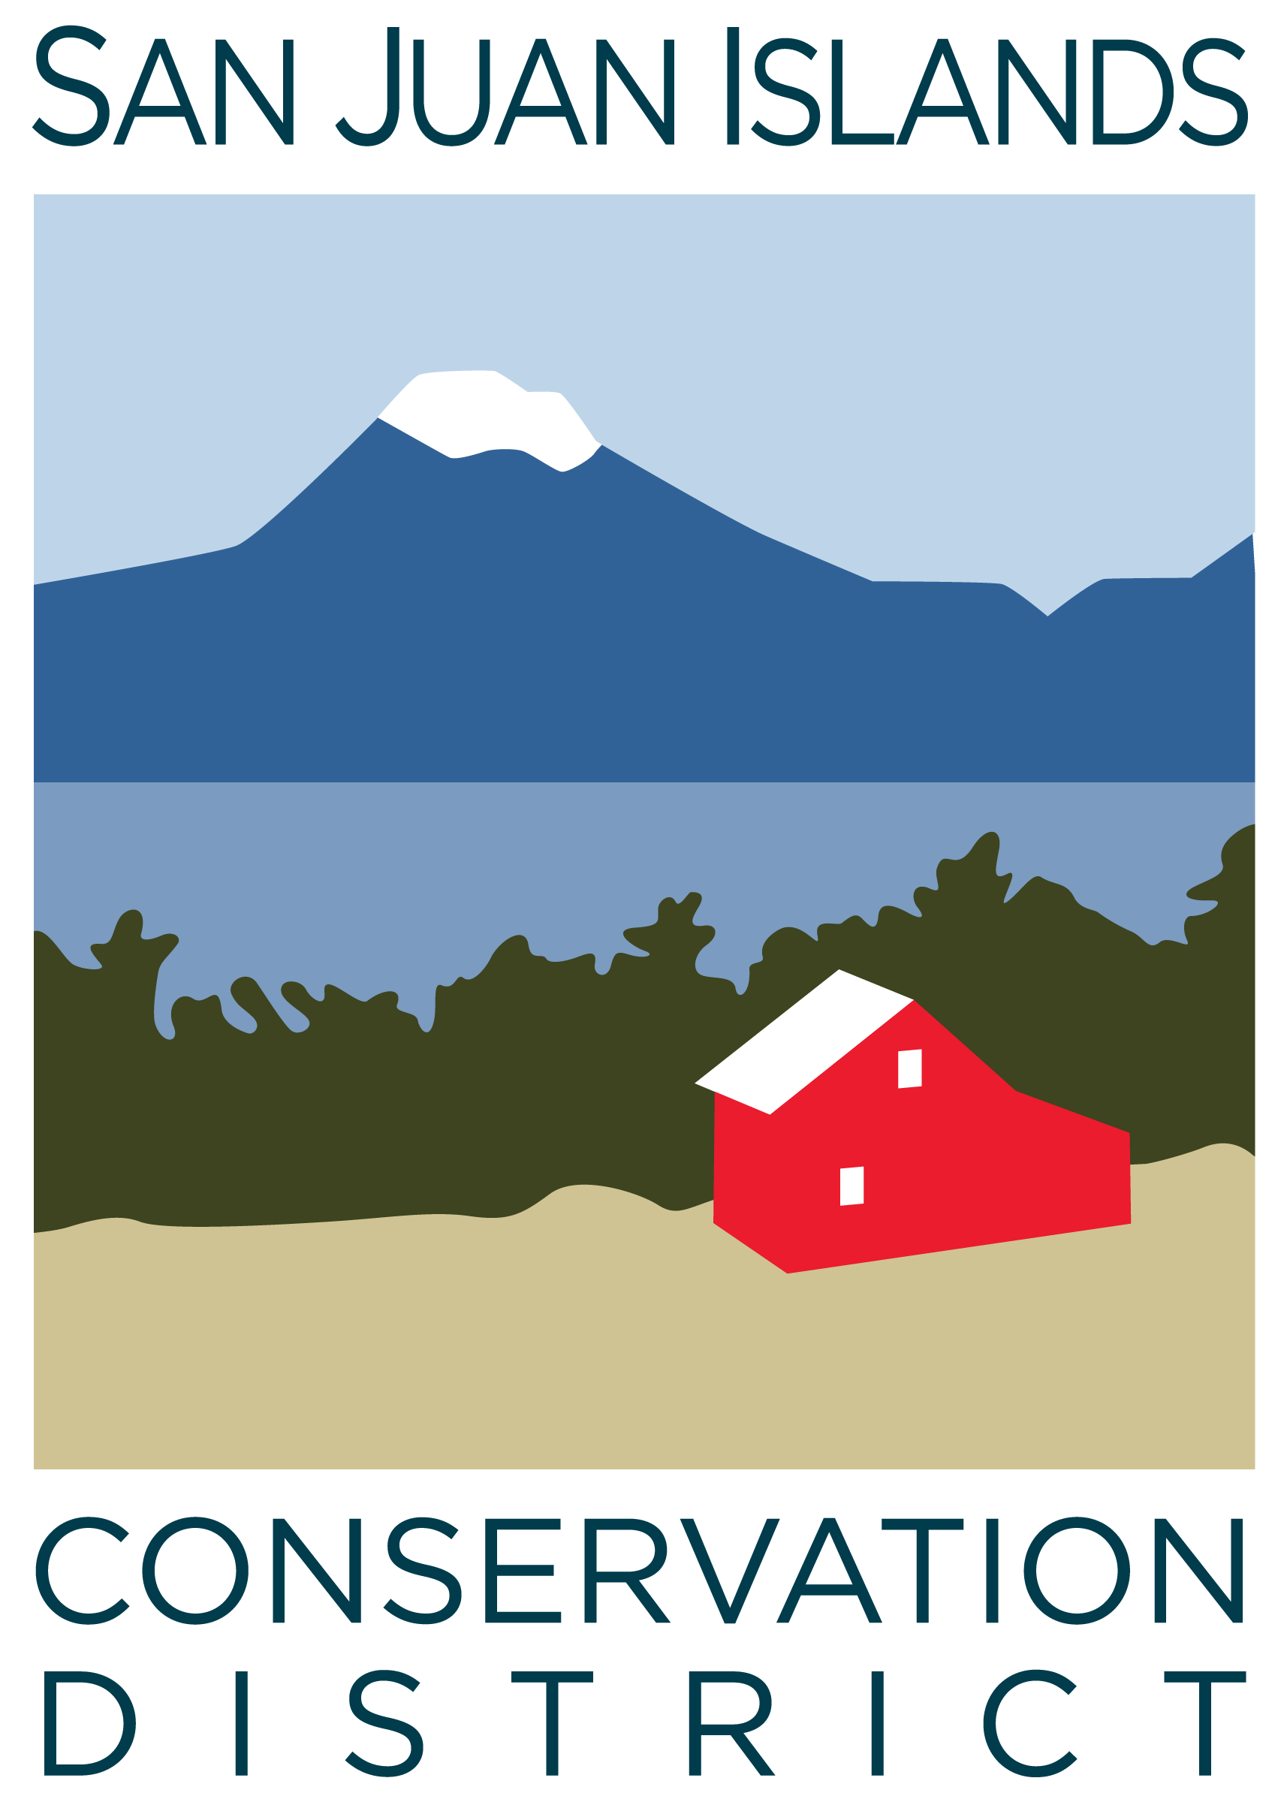
San Juan Islands Conservation District
BOARD OF SUPERVISORS
REGULAR MEETING MINUTES

Date: | December 22, 2023
Time: | 8:30am – 10:30am
Place: | 530 Guard Street, Friday Harbor, WA 98250  And online via Zoom
Attending Supervisors: | Carson Sprenger, David Bill, Vicki Heater, Lynn Bahrych, Claire Crawbuck
Attending Associates: | Jim Skoog
Absent: | Lynn Bahrych
Partners: | Kathy Smith, NRCS
Staff: | Paul Andersson, Tony Fyrqvist, Bruce Gregory
Public: | Andrew Jones

1 | Agenda Approval
 | Action Item: Motion to approve the Agenda was made by Claire, seconded by David. The motion was passed without discussion.
2 | November 2023 Regular Meeting Minutes Approval
 | Action Item: Motion to approve the November 2023 meeting minutes was made by David and seconded by Claire. (Due to Thanksgiving holiday at the end of November the meeting took place on 12/1/23). The motion passed.
3 | Financial Officers Report – October Financials
Action Item: Motion was made by David and seconded by Claire to approve the November 2023 financial documents, including:
- Balance Sheet
- Statement of Revenues and Expenses
- Credit Card Details
- Bank Reconciliation
- Adjusting Journal Entries
- Payroll
Discussion included Financial Manager’s comments provided in the SJICD Financial Summary 11/30/23 document.

The motion passed.

4 | Old Business
Topic: Office and property acquisition
- The District has still not received the Purchase and Sales Agreement or Lease Agreement from San Juan County.
- USDA Rural Development is evaluating the feasibility of using the existing commercial appraisal on the property in conjunction with processing the District’s loan application.
- Criteria under the USDA Rural Development loan program has no restrictions to subleasing public entities, however, subleasing to private entities is limited to 25% of the office space.
- Capital Fundraising Committee has met and discussed:
  - Target amount (such as $250,000) and justification (for purchase of new facility)
  - Timeline of fundraising in the Spring of 2024.
  - Fundraising events such as
    - Field walks
    - Lecture series
    - Speakers
    - Silent auction
    - Live auction
    - Farm hosted dinners
  - Marketing with a professionally designed flyer showcasing the vision for a Conservation Campus.
  - Building a foundation for fundraising with an Annual Report covering all District programs which would be mailed to residents of the County.
  - Communicating with local entities began with a contact with Orcas Island Community Foundation which informed the District of the multiple capital campaigns already planned on Orcas ranging from affordable housing to family resource center.
- There was discussion about the mission statement for the facility being separate from the mission statement of the District – it was agreed that this discussion should continue in the next board meeting.

5 | New Business
 | Action Item: Motion was made by David to adopt the 2024 Board Regular Meeting Schedule as presented. Claire seconded. The motion was approved.
 | Action Item: Motion was made by David to approve the update to the WSCC Cluster Engineer Interlocal Agreement SJICD has with Skagit, Whidbey and Whatcom CDs. Claire seconded. The motion was approved.
6 | Staff and Program Reports
 | Review of program activities as summarized on “Staff and Program Reports”.
7 | Subcommittees
Topic: Policy Subcommittee
Legal counsel has been engaged to review procurement policy and updated contract template(s).
8 | Upcoming Trainings/Webinars/Events
Topic: WADE Conference
The Washington Association of District Employees (WADE) Conference will be held at the Sleeping Lady Resort in Leavenworth on June 10-12, 2024. Discussed the possible VRBO alternative for lodging.
Topic: SJICD Office Closed
The District office will be closed for the week from Tuesday 12/26/23 through Friday 12/29/23 with staff working remotely or scheduled for vacations.

9 | Partner Reports
Kathy Smith:
- Looking forward to visiting SJICD.
- Expressed encouragement to applicants for NRCS funding to “Act Now” as the Inflation Reduction Act (IRA) is one of the single largest federal investments in climate and clean energy. Funding is available through the Environmental Quality Incentives Program (EQIP) and Conservation Stewardship Program (CSP).
- DNR has been completing thinning work for Decatur Homeowners Association.
10 | Public Comments
 | None.
11 | Idea Pot
Topic : Andrew Jones
- Andrew Jones attended the meeting as a member of the public. He and his family are Lopez Community Land Trust’s “Lopez Sound Farm and Forest Preserve” long-term lessees of 43 acres of forest and farmland.
- He stated that while he has been the last 2 years on Lopez, he has a keen interest in agriculture, climate change and the nonprofit mandate. His family has a long history of farming with his grandfather having been a Director of a Soil conservation District for 70 years while being forerunner in no-till farming practices in the 1960s.
- The Board encouraged him to consider an Associate Supervisor position and encouraged further conversation about his interests.
Topic: Land Bank
- The renewal of the Land Bank Conservation Area Real Estate Excise Tax is planned to be placed on the November 2024 Ballot.
- It was approved by voters for an additional 12 years in 2011 with a relatively close vote of 53% for and 47% against.
- The expiration date is in December 2026 allowing the Land Bank to bring it again in front of voters in 2025 in case of an unfavorable result in 2024.
- Discussed the political neutrality of Conservation Districts - along with the capacity of making a motion as a District to support specific bills which would have direct impact on conservation, climate change, soil health and other efforts of the District.
- The Conservation District works on multiple joint projects with the Land Bank.
- David presented a potential motion in the next meeting to support the renewal of Land Bank and requested it to be on the agenda for further discussion in the 12/26/24 Board Meeting.
Topic: Bruce Gregory
Bruce was recognized and gratitude was expressed for his continuing contributions to the District over the past 15 years. He has been assigned an “Emeritus” role for his involvement with the District after the official SJICD Resolution 2022-003 which was passed on his retirement on 4/26/22.

Topic: Board Retreat
There was general support for a Board meeting with a date to be determined.
Topic: Ag Summit in February
It was agreed to discuss this further in the next meeting.
12 | Adjournment 10:30am

Next Meeting: | Friday, January 26, 2024 from 8:30am to 10:30am.

