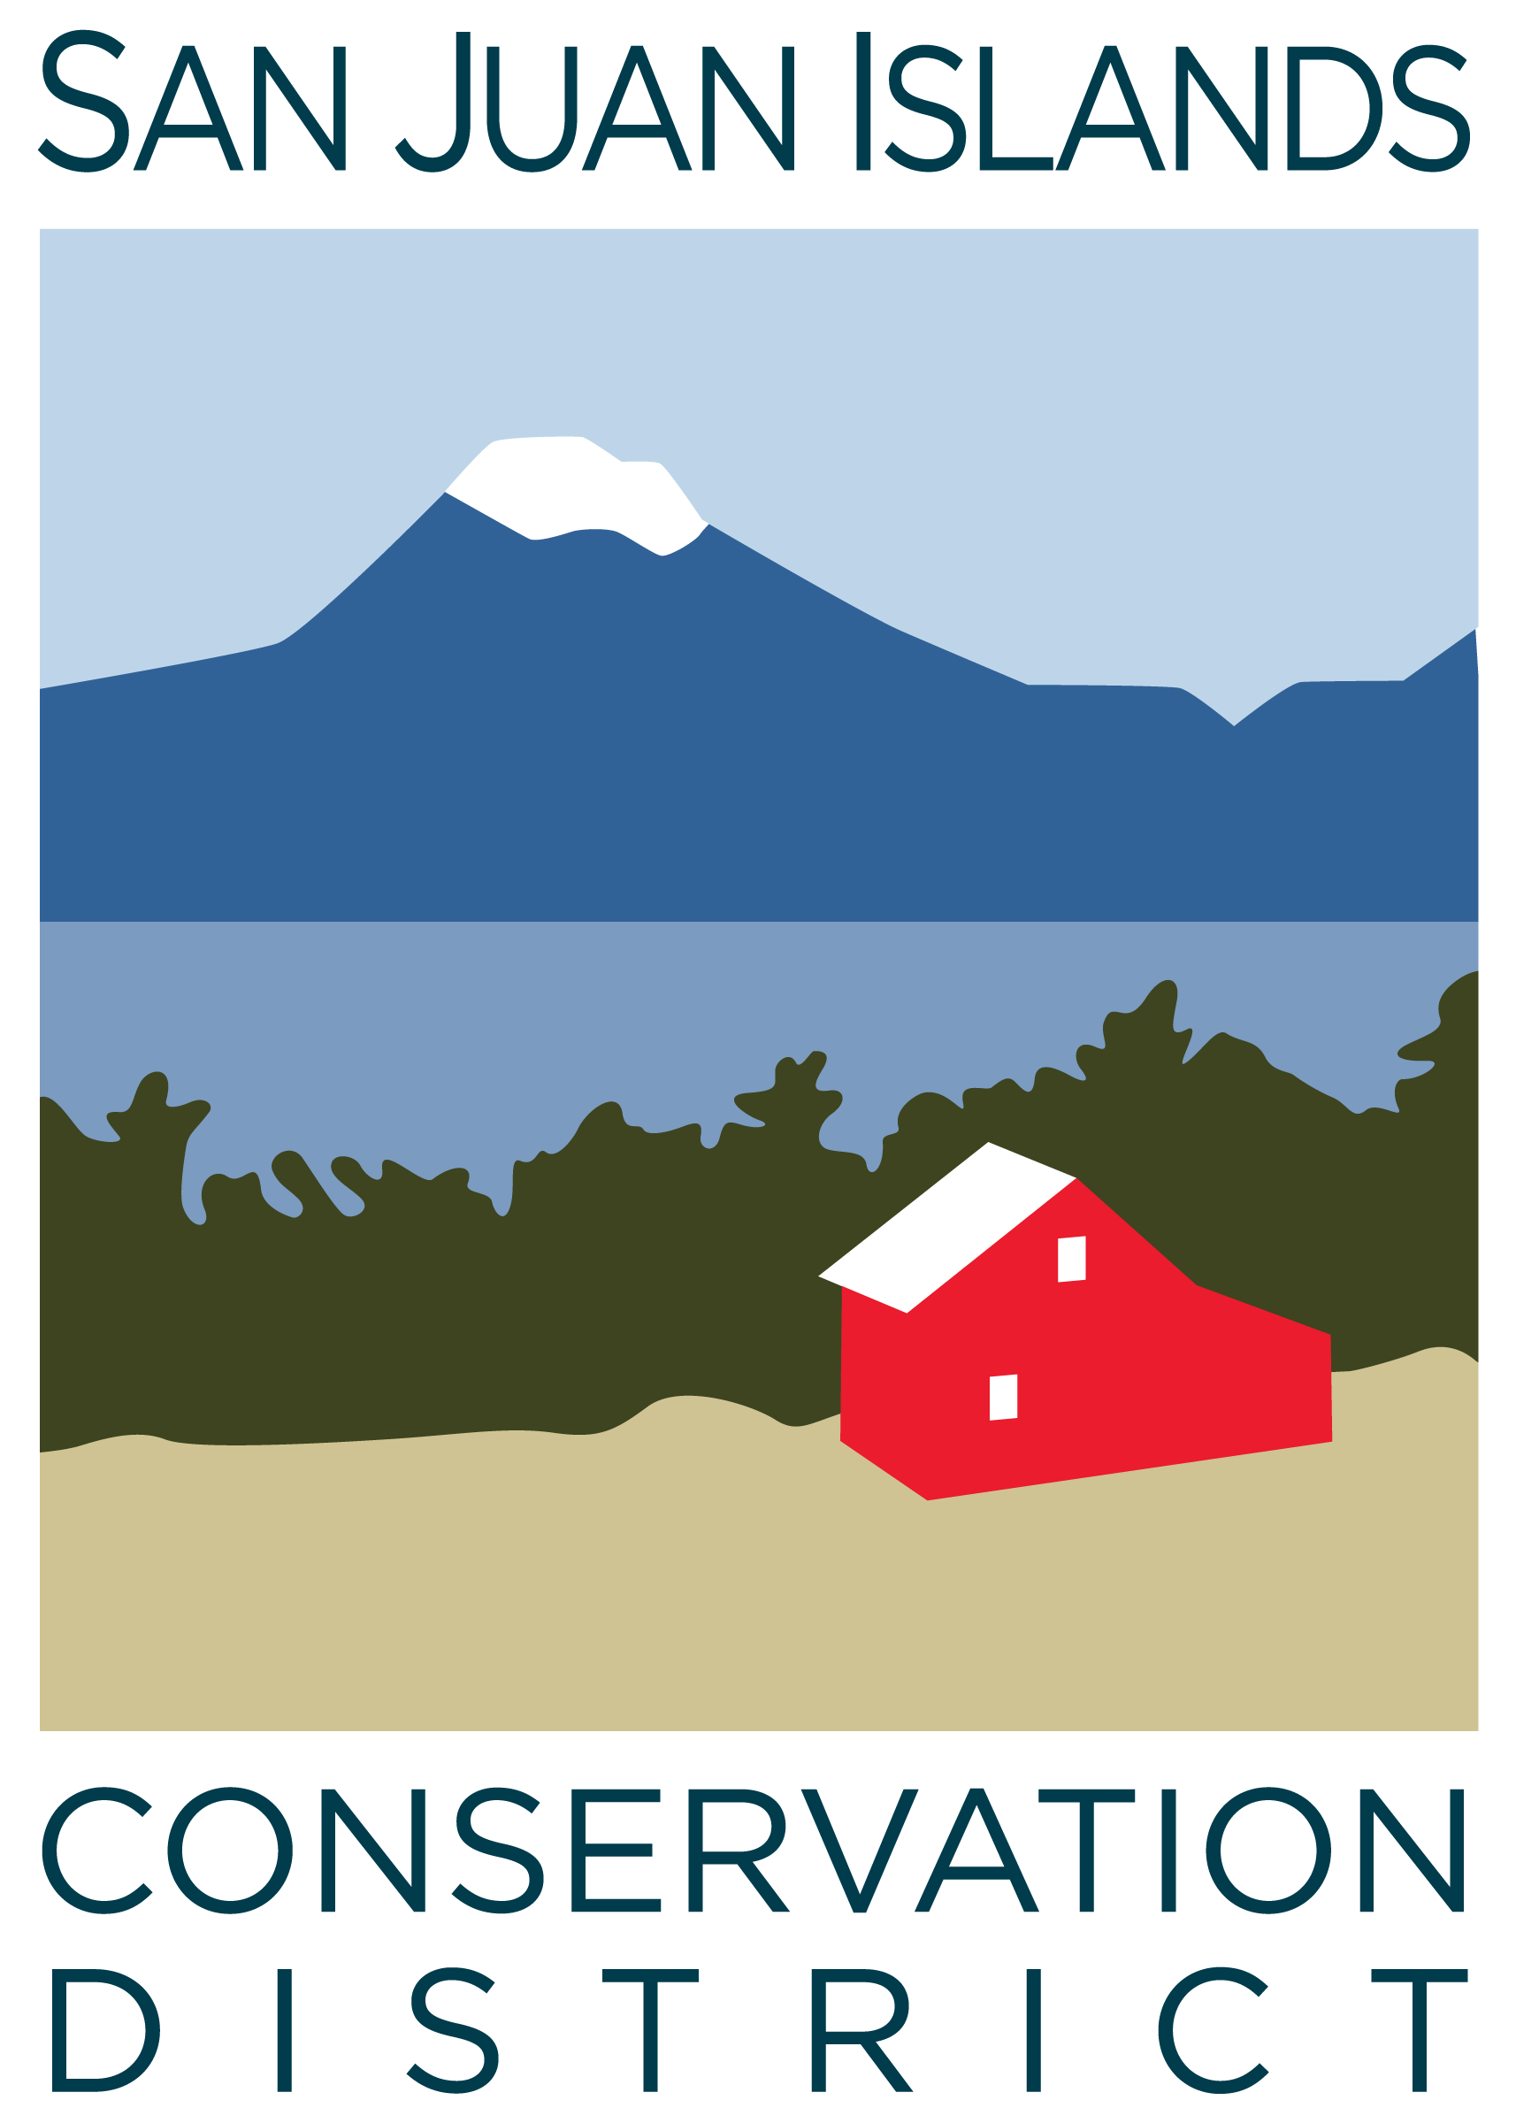
San Juan Islands Conservation District
BOARD OF SUPERVISORS
REGULAR MEETING MINUTES

Date: | March 22, 2024
Time: | 8:30am – 10:30am
Place: | 530 Guard Street, Friday Harbor, WA 98250  And online via Zoom
Attending Supervisors: | Carson Sprenger, David Bill, Vicki Heater, Lynn Bahrych, Claire Crawbuck
Attending Associates: | Jim Skoog
Absent: | Tony Fyrqvist
Partners: | Kathy Smith, NRCS; Alan Chapman, WACD
Staff: | Paul Andersson
Public: | Adam Greene

1 | Agenda Approval
 | Action Item: Motion to approve the Agenda was made by David, seconded by Clare. The motion passed.
2 | January 2024 Regular Meeting Minutes Approval
 | Action Item: Motion to approve the February 2024 meeting minutes was made by Lynn and seconded by David. The motion passed.
3 | Financial Report – February Financials
Action Item: Motion was made by David and seconded by Lynn to approve the February 2024 financial documents, including:
- Balance Sheet
- Statement of Revenues and Expenses
- Credit Card Details
- Bank Reconciliation
- Adjusting Journal Entries
- Payroll
Discussion included:
- An additional amount of CTA funding from the legislature through the WSCC, amounting to about $209,000.
- A grant for communications and outreach was received for $18,000. An additional grant has been applied for to help with the move and to organize files.
- The Island Marble Butterfly Volunteer program was partially funded and moved to SJICD from local non-profit On Sacred Ground where it was formerly administered.
The motion passed.

4 | Old Business
Discussion Item - Property Acquisition:
- The Purchase and Sale for the District property acquisition is expected to close on or after April 8, 2024. The interest rate is predicted to be 3.5% at that time.
- April 1 is still seen to be a logistically suitable date to provide the notice to the current landlord.
- The sublease form has been drafted and worked on by Paul and Lynn but is not ready for use at this time. Other, simpler samples of commercial leases will be considered. Once a tenant has been selected, an appropriate lease will be drafted for review by the tenant. The Ag Guild will be looking at the building with Paul and is especially interested in space for cold storage.
Discussion and Action – Board Retreat: The Board retreat has been set for April 12 from 9 am to 3 pm at the Spring Street campus building, with a forest tour to be led by Carson and Jim. There will be no facilitator. A general outline of topics will be prepared and distributed before the retreat. The idea is to allow brainstorming and open-ended long-term planning. David moved to adopt this plan, Lynn Seconded, and the motion passed.
 | Discussion Item - 2024 Elections: The District held its annual election. Clare Crawbuck was elected as supervisor. Vicki Heater’s application for the appointed supervisor position is still pending and will be considered by WSCC at its May regular meeting. Generally, the election went well with more than the usual number of votes being cast. Clare was elected unanimously.
 | Discussion Item - Legislative Updates: $3.5 million for CTA was authorized and signed into law by the Governor. There will be a CD meeting in Ellensburg to discuss the legislative requests for the 2025 session on May 29 and May 30th. The biochar bill that would remove biochar kiln operations from being considered “barrel burns” and therefore illegal, is on the Governor’s desk expected to be signed.
5 | New Business
 | Discussion of board/staff participation in WACD Renewable Energy Task Force: Carson volunteered to participate in the WACD Renewable Energy Task force specifically related to developing position statements for CDs on solar and hydro power. Carson will attend meetings and report back to the board for input on the topics and SJICDs position related to each.
 | Discussion and Action - Agrivoltaics in San Juan County and OPALCO Bailer Hill Project: The board approved a public comment letter to be sent to San Juan County Council and Department of Community Development in support of the Bailer Hill Agrivoltaic Solar project. The letter was drafted by David Bill and edited by Lynn, with further contributions from Carson. After a robust debate, David made the motion to send a letter of support. Lynn seconded the motion. The motion passed 4-1.
6 | Staff and Program Reports
A truncated review of the Staff and Program Reports was provided due to time constraints. Discussion included ongoing development of new programs and funding for homeowners and neighborhoods to tackle wildfire mitigation work.
Discussion Item: BLM National Monument Advisory Committee – Discussion resulted in agreement that Clare Crawbuck is the preferred SJICD representative to sit on the SJI National Monument Advisory Committee, with the understanding that Cathi Winnings could also be nominated by the CD to serve on this committee. Paul and Claire will follow up with application materials.
7 | Subcommittees
 | Discussion Item: The Fundraising Committee met with the board and staff of the San Juan Island Community Foundation and are developing a strategy for fundraising for SJICD programs with SJICF.
8 | Upcoming Trainings/Webinars/Events
The Ag Summit was extremely successful, with lots of CD participation as a collaborating sponsor, and multiple speaking engagements.

WADE Conference June 10-12
- Attendance at the Conference was encouraged by past attendees and the event was described as fun, stimulating and engaging while providing learning and networking opportunities.
- Several supervisors and several staff members are planning to attend this year.
9 | Partner Reports
Alan Chapman:
- Mentioned the “all CD” meeting hosted by WSCC in Yakima on March 26-27th, plus the WACD legislative planning session in Ellensburg at the end of May. The WACD planning meeting will be in person and hybrid. The WSCC meeting is in-person only.
Kathy Smith:
- Reported that the biochar bill had passed the state legislature to allow kiln burning, and the that next CSP round of funding is coming up.
10 | Public Comments
 | Adam Greene spoke in favor of the OPALCO solar project that will positively affect his farm, Oak Knoll Farm, on San Juan Island. He was invited to present his opinions during the agrivoltaics discussion earlier in the meeting.
11 | Idea Pot
 | Topic : Scientists from UW will perform field trials of a new method of separating carbon from seawater and producing green energy sometime in the summer of 2024 in the San Juan Islands.
12 | Adjournment 10:35am
Next Meeting: |  | Board Retreat – Friday April 12, 9am-3pm, 915 Spring Street  Regular Meeting - Friday, April 26, 2024, from 8:30am to 10:30am

