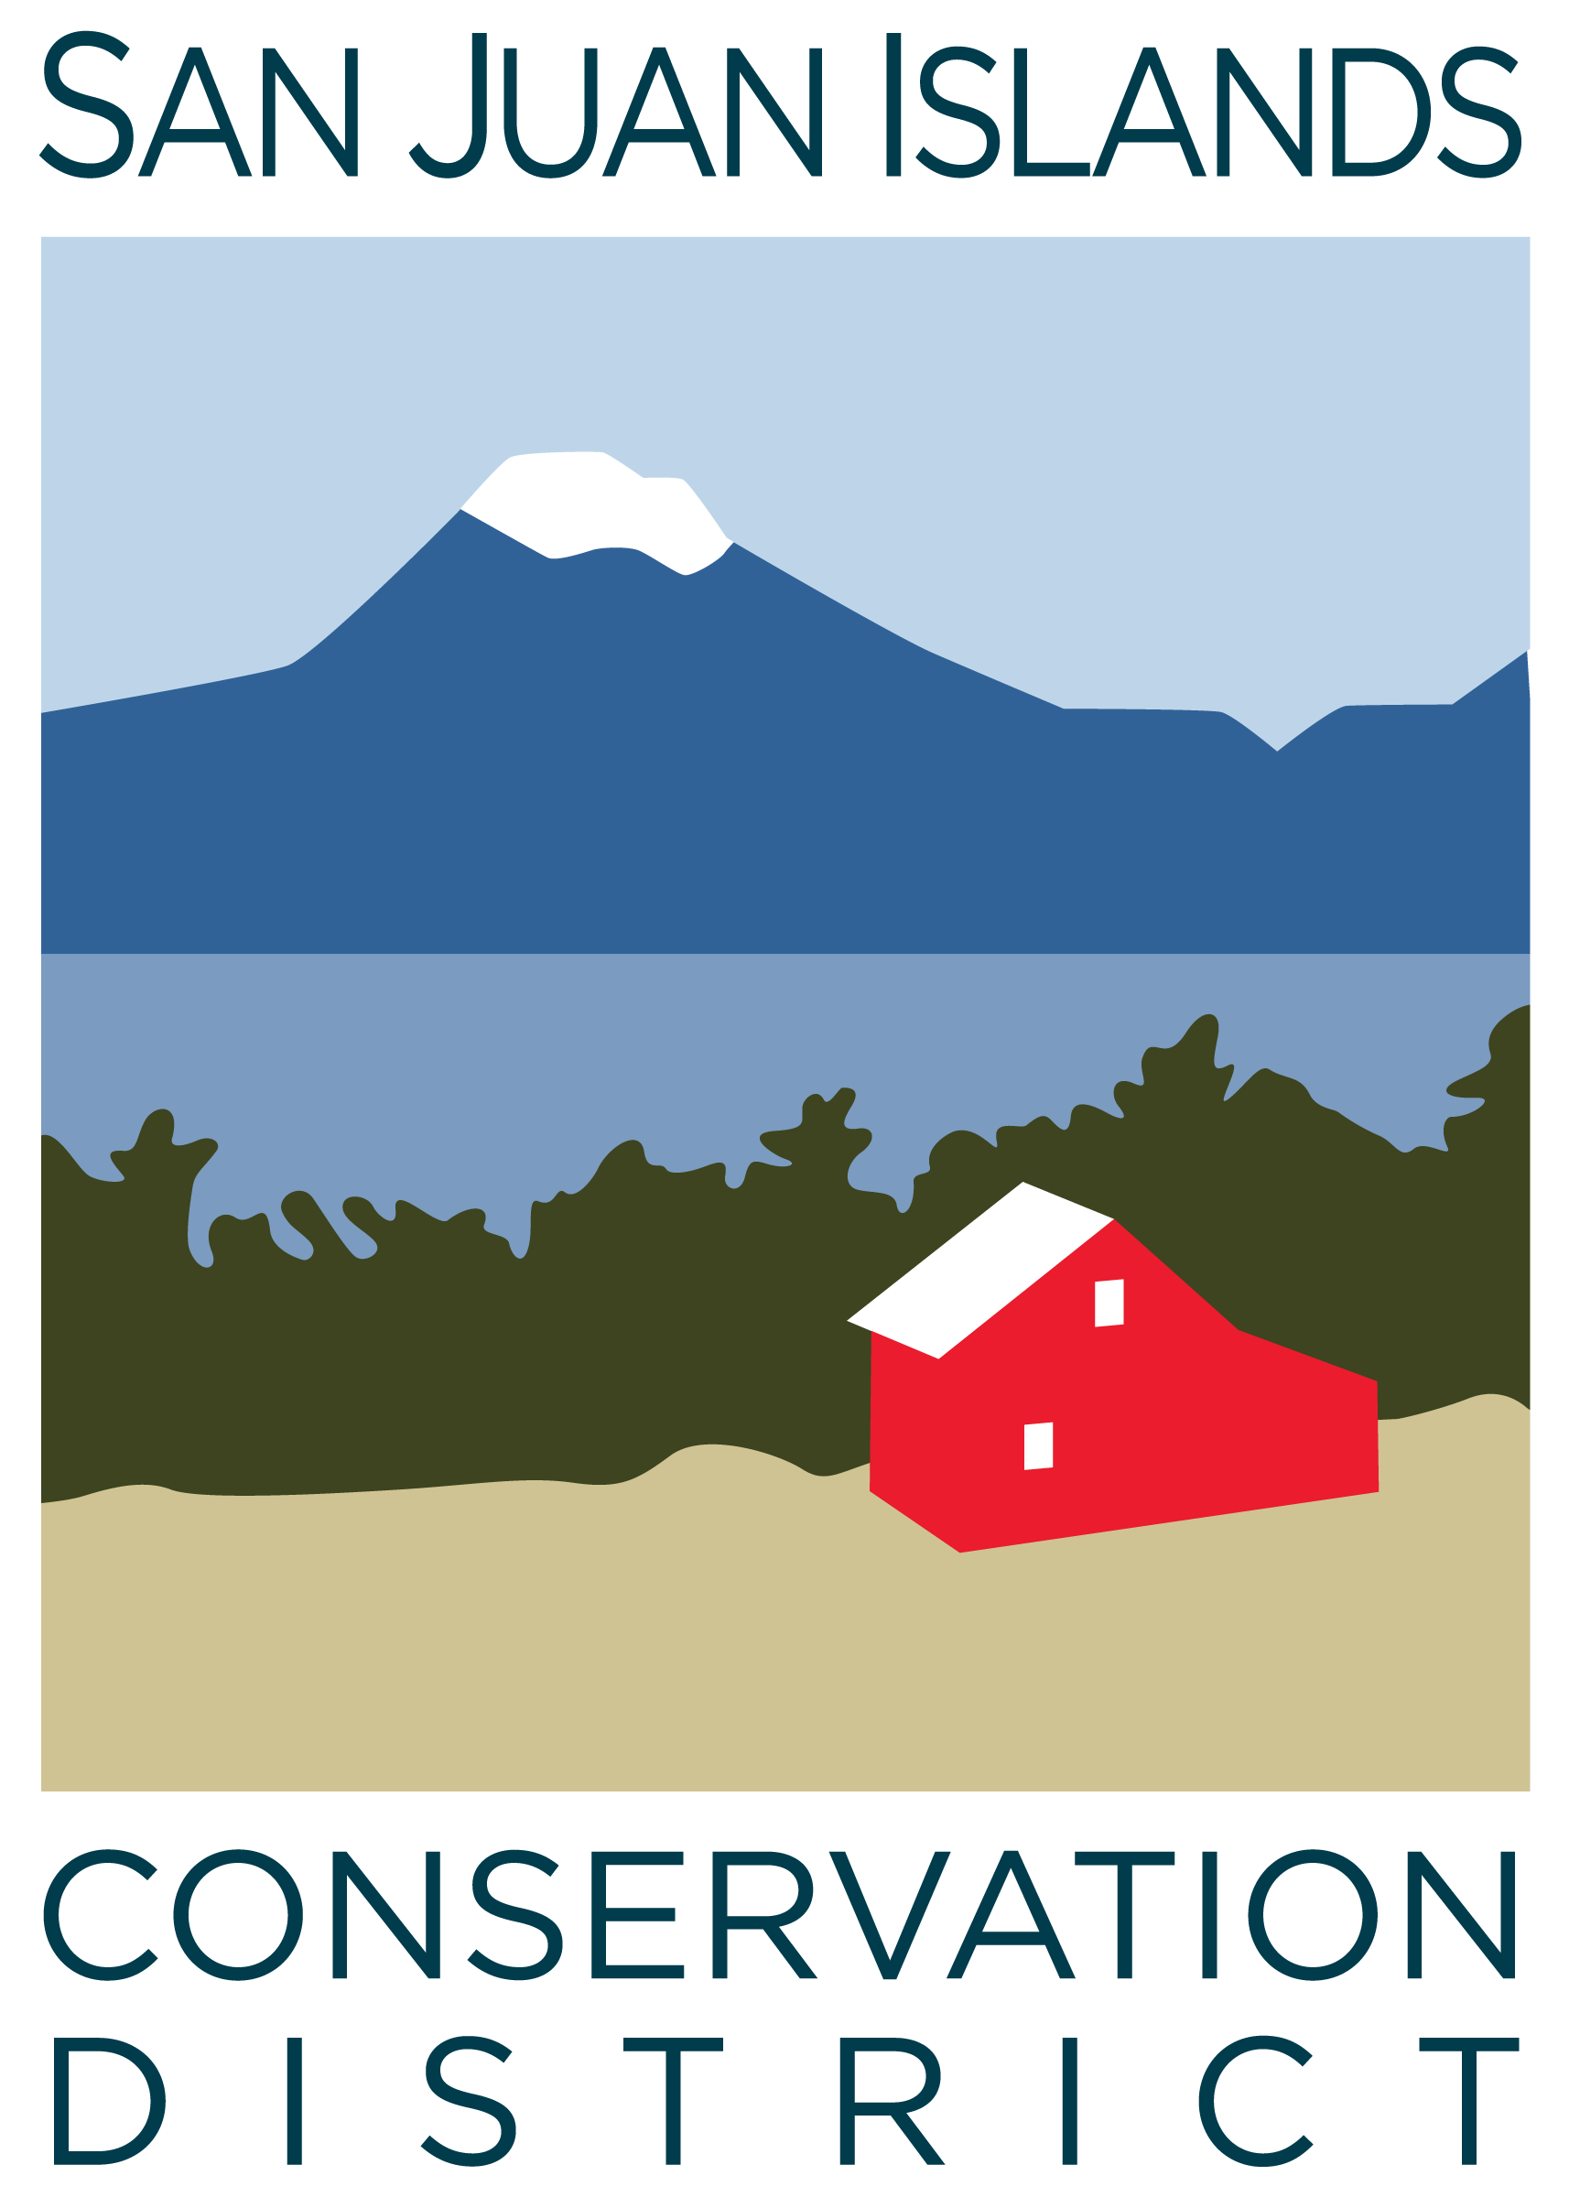
San Juan Islands Conservation District
BOARD OF SUPERVISORS
REGULAR MEETING MINUTES

Date: | October 25, 2024
Time: | 9:00am – 11:00am
Place: | 915 Spring St. Friday Harbor, WA 98250  And online via Zoom
Attending Supervisors: | David Bill, Roger Bairstow, Vicki Heater
Partners: | Alan Chapman, Washington Association of Conservation Districts (WACD) NW Region Representative
Staff: | Paul Andersson, Tony Fyrqvist
Public: | Ron Zee

 | Welcome and Introductions
 | General discussion regarding application of best management practices and cost share on local farms.
1 | Agenda Approval
 | Action Item: Vicki made a motion to approve the agenda, Roger seconded. An amendment was proposed by David to move the Partner Reports and Public Comments to the beginning of the Agenda. The amended motion passed.
2 | Partner Reports
Alan Chapman:
- In the WACD board meeting of 10/21/24 financials were reviewed and the budget was updated.
- Plant Materials Center (PMC) sales picked up during the month and are now ahead of last year. PMC has implemented a water conserving variable pump system.
- The evaluation and job description were completed for the Executive Director.
3 | Public Comments
 | Ron Zee was recognized as a former District Supervisor, for his efforts with Youth Conservation Corps (YCC), and for the continuous support of the District through Madrona Institute. Ron mentioned that he will be stepping down as the President of the Madrona Institute. The new President is Snohomish Conservation District Executive Director Linda Lyshall.
4 | September ’24 Regular Meeting Minutes Approval
 | Action Item: Vicki made a motion to approve the 9/27/24 minutes and was seconded by Roger. The motion was approved.
5 | Financial Report – September 2024 Financials
Action Item: September Financials - Motion was made by Roger and seconded by Vicki to approve the September 2024 financial documents, including:
- Financial Summary
- Balance Sheet
- Statement of Revenues and Expenses
- Credit Card Details
- Bank Reconciliation
- Adjusting Journal Entries
- Payroll
The Financial Manager made the following additional comments regarding information received since preparing the Financial Summary:
- Enduris Insurance has informed the District that their “Impersonation Fraud Coverage” has a $1,000.00 deductible and the District will be receiving $3,575.72 of the $4,575.72 payroll fraud incident which occurred in August 2024.
- The District has collected an additional $51,549 bringing the Operating Account balance to over $200,000 at the time of the Board Meeting.
- Despite the downswing demonstrated in the operating account balance graph, due to collection of accounts receivable, and management of projected large payments, the balances are deemed to be sufficient into the future without needing to access reserve funds. Operating balances are carefully monitored each day.
The motion passed.
Discussion:
- Discussed Grant Pipeline report showing close $2 million in proposed new grant applications.
6 | Old Business
Discussion Item: Conservation Campus Grand Opening – updated on planning efforts for the ribbon cutting event:
- Conservation Campus grand opening and ribbon cutting event has been scheduled for 11/14/24 from 3:00pm – 6:00pm - with ribbon cutting at 5:00pm.
- Discussed buffet style food offerings, with some items have already been donated, and budget for the event.
Action Item: Rock Island Communications Easement - Motion was made by Vicki and seconded by Roger, to approve the easement for fiber internet to CD campus and neighboring buildings. The motion passed.
7 | New Business
 | Action Item: Executive Director Compensation - Vicki made a motion to approve the wage adjustment for Executive Director based on performance and other factors. She was seconded by Roger and the motion passed.
Discussion Item: Youth Conservation Corps (YCC) funding status was discussed in depth including:
- Income, expenses and fundraising.
- Importance, history and success of the program.
- Creation of a fund at San Juan Island Community Foundation (SJICF) for raising money to support YCC.
- Ron Zee provided a donation to YCC for $10,000 from the Madrona Institute and the SJI License Plate Program.
 | Action Item: Resolution 2024-004 - Vicki made a motion to approve Resolution 2024-004 to establish a non-profit fund at SJICF for raising money to support YCC. Roger seconded the motion. Discussion topics included the 1% fee charged by SJICF.
8 | Staff and Program Reports
 | Discussion: Information on the Staff and Program report was summarized.
9 | Subcommittees
Discussion:
- Forest Health Subcommittee is being discontinued as the objectives have been achieved and programs are running.
- Policy Subcommittee will continue primarily to develop a policy regarding the role or need of an Associate supervisor.
- The District has established a Safety Committee to comply with Labor and Industry guidelines.
- Diversity, Equity, Inclusion (DEI) Subcommittee is continuing to establish plans and guidelines for tribal engagement and District staffing.
- Landscaping subcommittee is continuing to take care of District’s landscaping needs.
10 | Recent & Upcoming Trainings/Webinars/Events
Discussion:
- Executive Director attended the WACD NW Regional Meeting on 10/24/24 which covered new and existing resolutions and their potential paths through State Legislature.
- A District staff member will be attending the WACD Annual Conference in Spokane which is held Dec 2-4, 2024
11 | Idea Pot
Discussion:
- Chainsaw training for public.
- Farm Tours: Demonstration of Best Management Practices (BMPs) on site, providing handouts at farms related to the Conservation District.
- Engaging the County Land Bank with preservation of farmland.
- Development of a revolving loan fund with Lopez Food Center to work in conjunction with District Cost Share program
12 | Public Comments
 | None.
13 | Adjournment 11:00am
Next Meeting: |  | Regular Meeting - Friday, November 22, 2024, from 9:00am to 11:00am

