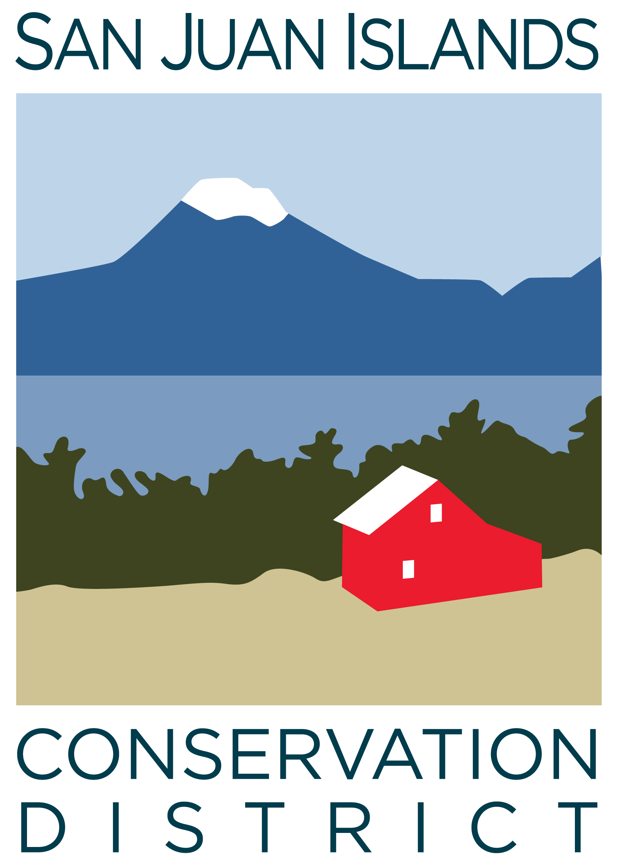
San Juan Islands Conservation District
BOARD OF SUPERVISORS
REGULAR MEETING MINUTES

Date: | December 1, 2023
Time: | 8:30am – 10:30am
Place: | 530 Guard Street, Friday Harbor, WA 98250  And online via Zoom
Attending Supervisors: | Carson Sprenger, David Bill, Vicki Heater, Lynn Bahrych, Claire Crawbuck
Attending Associates: | Jim Skoog
Absent:
Partners: | Jean Fike, WSCC Puget Sound Regional Manager; Alan Chapman WACD NW Region Representative
Employees: | Paul Andersson, Tony Fyrqvist
Public: | None

1 | Agenda Approval
 | Action Item: Agenda was approved by consensus without any changes.
2 | October 2023 Regular Meeting Minutes Approval
Action Item: Motion to approve the October 2023 meeting minutes was made by Lynn, seconded by Vicki.
Brief discussion about the changed format of the minutes making it easier to read while still being able to include all relevant information.
The motion passed.
3 | Financial Officers Report – October Financials
Action Item: Motion made by Vicki and seconded by Lynn to approve October 2023 financial documents, including:
- Balance Sheet
- Statement of Revenues and Expenses
- Credit Card Details
- Bank Reconciliation
- Adjusting Journal Entries
- Payroll
Discussion included Financial Manager’s comments provided in the SJICD Financial Summary 10/31/23 document. The motion passed.
Other discussion included:
- Notification received from the State Auditors Office regarding a 2-year audit. Follow-up will be made as traditionally conservation districts are audited on a 3-year cycle.
- Recommendation by Vicki - in light of upcoming reorganization of internal reporting and hierarchies to improve operational efficiency - to further study the budgetary impact of the prior Board decision to appropriate funding to hire a part- or full-time operations assistant.
4 | Old Business
Topic: Office and property acquisition
Discussion of next steps in the property acquisition process:
- Continuing conversations with County Manager, Attorney and Facilities Manager regarding steps of acquisition and possible lease at monthly rental rate of $1 per sq ft ($5,500/mo).
- Subleasing space in the facility will reduce the financial impact while realizing the “Conservation Campus” model.
- Need for additional space due to District growth.
- All pending grant applications are being executed resulting in continuing future growth.
Action Item: Motion was made by Lynn to approve San Juan Islands Conservation District Resolution # 2023-003, stating intent to pursue USDA Rural Development loan funding for facility acquisition. The motion was seconded by David.
Discussion included District conversations with the County Manager and the County Facilities Manager about finalizing a Purchase and Sale Agreement, possible lease terms to cover delays in closing, and public hearings to be held prior to the sale.
The motion passed.
Topic: SJICD Board Self-Review
Board member comments to an evaluation questionnaire were compiled by David and reviewed.
Emphasis was placed on the importance of outreach, locating and training of new Supervisors.
In summary, the evaluation questionnaire was deemed to be easy to complete, the Board appears to be well run and adheres to the Governance Policy.
5 | New Business
Topic: Fundraising Committee
Discussed:
- Various potential fundraising events of different islands.
- The success of Spokane Conservation District funding the Quarry conservation and business campus particularly as to the importance in a fundraiser to have ½ to ¾ of in place from major donors prior to opening to the general public.
- The assistance Spokane received from Community Economic Revitalization Board (CERB) with realizing their vision.
6 | Staff and Program Reports
Review of program activities as summarized on “Staff and Program Reports”.
In depth discussion about pasture-prairie restoration, with Associate Supervisor commenting on specific prairies restoration actions on a private 50-acre parcel on San Juan Island – and a possible tour of the site.
Emphasized the importance of scale and connectivity.
7 | Subcommittees
Topic: Policy Subcommittee
Discussion about the Procurement Policy having been finalized internally and sent to legal counsel for review.
Topic: Forest Health Subcommittee
Discussion focused on the Community Wildfire Protection Plan (CWPP) update process, highlighting an initial stakeholder meeting scheduled for December 14^{th.}
8 | Upcoming Trainings/Webinars/Events
Topic: WACD Updates
District Manager attended the 2023 annual WACD meeting (Nov 27-29) held in Wenatchee and debriefed the event:
- David Vliet from Kitsap Conservation District is the new WACD Northwest Area Director.
- Alan Chapman is resigning from his position with WACD, and is considering running for Supervisor at Whatcom CD.
- The SJICD-sponsored resolution 2023-02 passed without discussion. The resolution helps direct WACD resources toward changing state law to allow the use of food-grade biochar as an additive to livestock feed to reduce methane production and greenhouse gas emissions and to improve soil and animal health
- David Bill was honored for 5 years of service as a Supervisor, with other milestones being 10yrs – 20 yrs – 25yrs -30yrs – 40yrs.
- Project of the year was Columbia Basin CD’s Odessa Groundwater Replacement Program (OGWRP) which has been under development for several years to design and construct the infrastructure needed to deliver water to an additional 65,000+ acres.
- Trout Unlimited program and beaver replacement in Methow Valley and Kitsap County.
- Enduris presentation regarding risks and various training available to Districts.
9 | Partner Reports
Jean Fike:
- WACD Annual Meeting was well attended by ideologically diverse conservation districts.
- James Thompson was named Executive Director of Washington State Conservation Commission.
- Commission is working on new and continuing additional funding for programs
- Commission support community engagement plan.
Alan Chapman:
- All resolutions passed at WACD Annual Meeting.
- Plant Materials Center is continuing to fulfill Conservation Districts need for plants.
- Mark Craven was elected as WACD Treasurer.
- While the Rates and Charges System is established by RCW 89.08.405 there is a movement from state level to a more local decision making to set the limit in light of the recent raising the assessment allowed per acre.
10 | Public Comments
 | None.
11 | Idea Pot
12 | Adjournment 10:30am

Next Meeting: | Friday, December 22, 2023 from 8:30am to 10:30am.

