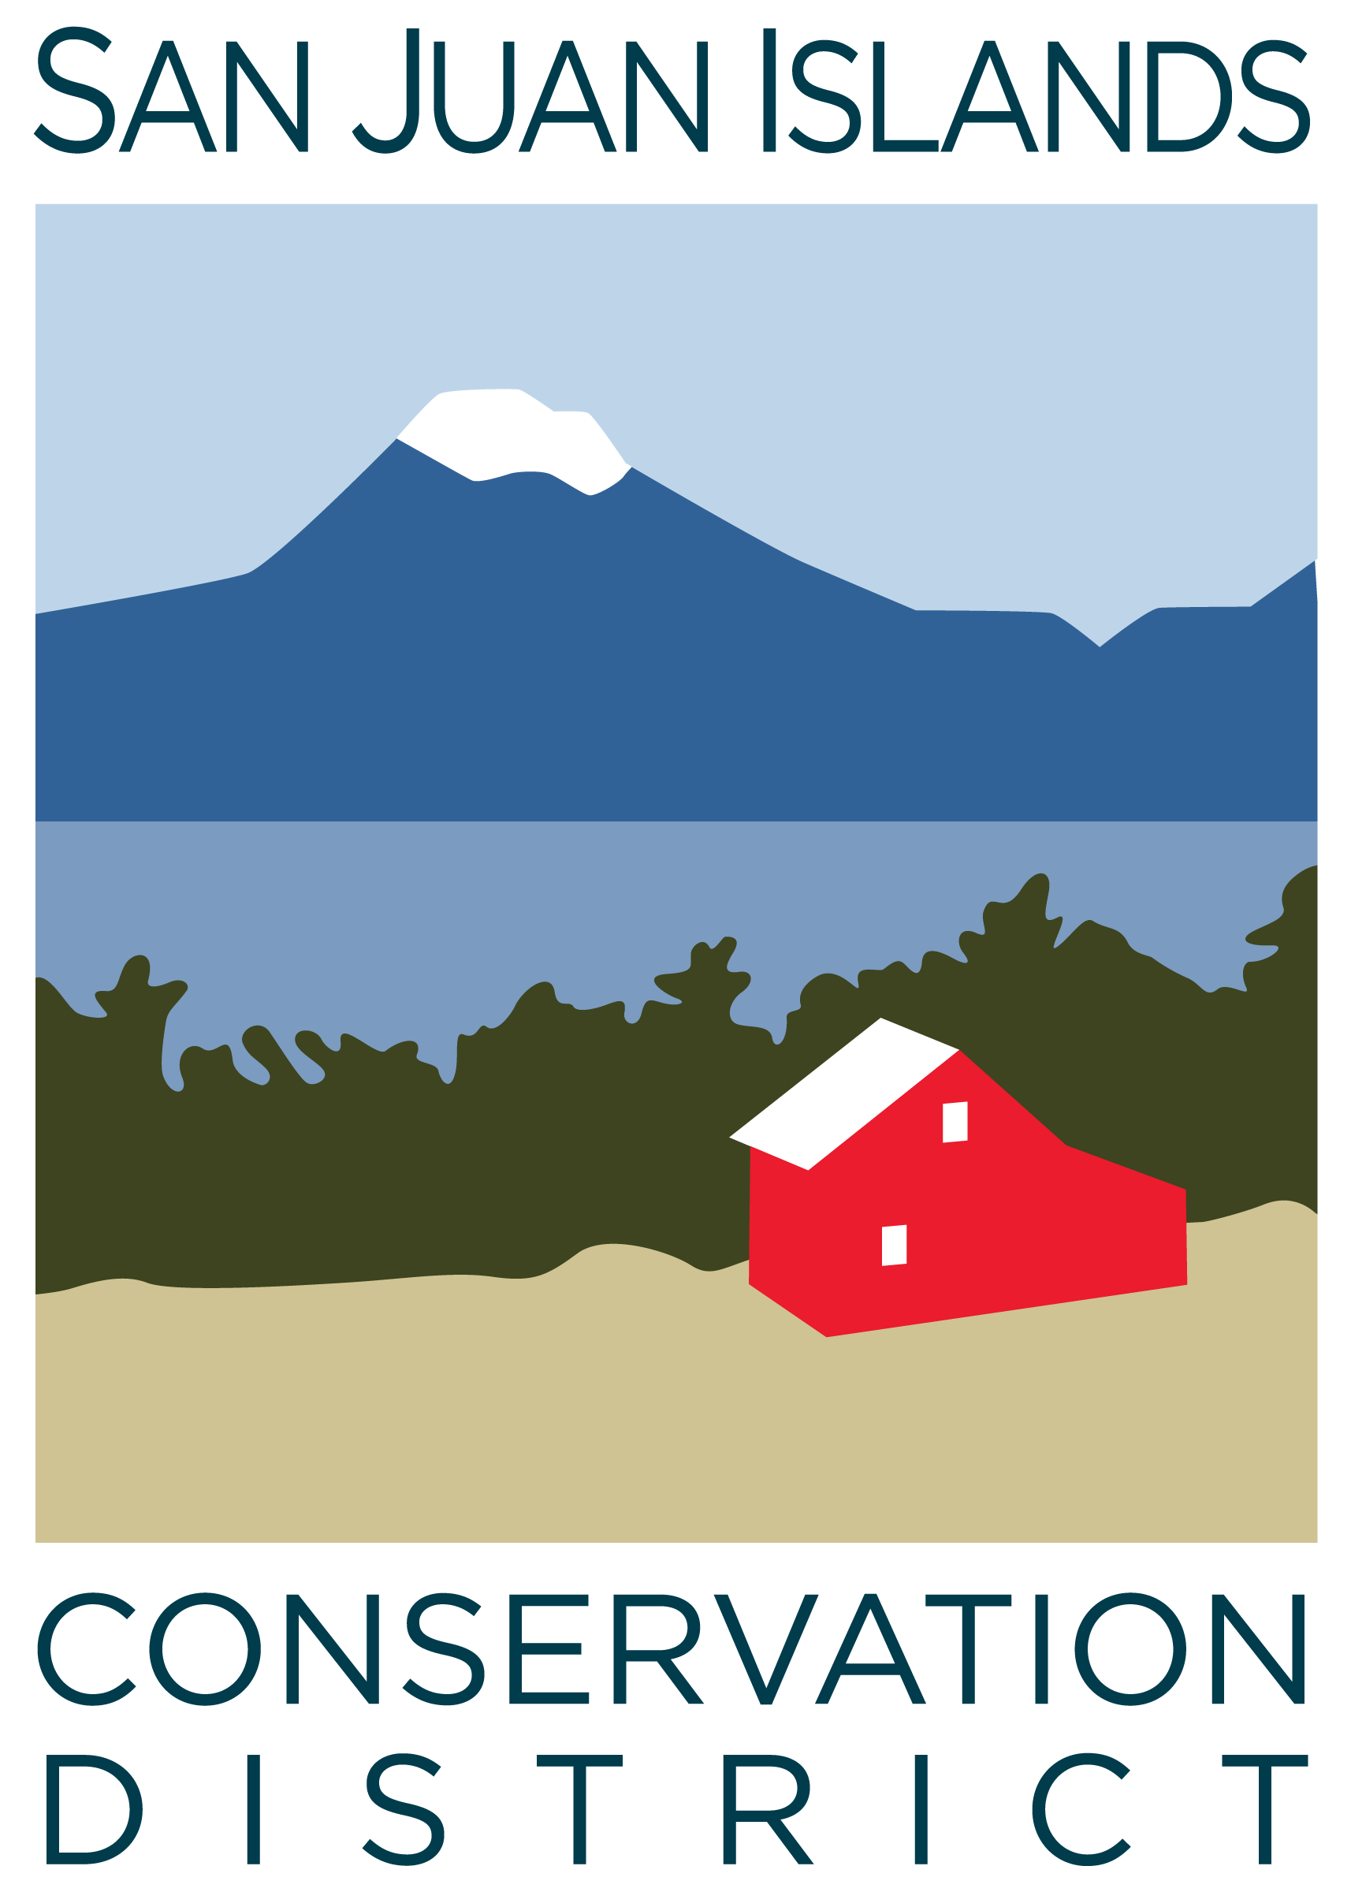
San Juan Islands Conservation District
BOARD OF SUPERVISORS
REGULAR MEETING MINUTES

Date: | January 24, 2025
Time: | 9:00am – 11:00am
Place: | 915 Spring St. Friday Harbor, WA 98250  And online via Zoom
Attending Supervisors: | David Bill, Lynn Bahrych, Roger Bairstow, Vicki Heater, Claire Crawbuck
Partners: | Kathy Smith, NRCS; Alan Chapman, Washington Association of Conservation Districts (WACD) NW Region Representative
Staff: | Paul Andersson, Tony Fyrqvist
Public: | Andrew Munson

 | Welcome and Introductions – 9am
1 | Agenda Approval
Lynn called the meeting to order and the Agenda was approved by consensus after the following changes were made under 7. New Business:
- Addition of Legislative Priorities.
- Removal of Discussion of SAO Audit preliminary feedback, which will be covered in the Feb-25 Board Meeting after the Audit has been completed.
- Removal of Board Self Review which will also be discussed in the next Board Meeting.
2 | December ’24 Regular Meeting Minutes Approval and January ’25 Special Meeting Minutes Approval
 | Action Item: David made a motion to approve both the 12/20/24 Regular Meeting Minutes and the 1/10/25 Special Meeting Minutes. He was seconded by Claire. The motion was approved.
3 | Public Comments
 | Andrew Munson from the San Juan County Noxious Weed Program mentioned that he was attending the meeting to observe and learn about operations of the Conservation District.
4 | Partner Reports
NRCS, Kathy Smith
- Discussed Task Orders, which have been processed and forwarded for further review and approval.
- Task Orders specially emphasized included Forest Management Plans and EQIP (Environmental Quality Incentives Program).
- Cathi Winings from the Conservation District will be attending a 2-day State Forestry Meeting.
- Local concerns, in light of the large fires in Los Angeles, include the DNR Red Zone designation of the County, local overstocked forests and needed fuel breaks.
WACD Alan Chapman:
- Executive Director performance review survey has been sent out and results are being compiled and analyzed
- Long range planning workshop is planned for May after the Legislature has completed their Spring Session.
- Advocacy work at the Legislature is continuing.
5 | Financial Report – November and December 2024 Financials
 | Discussion: December financials were received from the accountant late on 1/23/25 and provided to the Board members early morning on 1/24/25 with insufficient time for full review. They will be reviewed at the Feb-25 Board Meeting. The Financial Officer presented the year-end 12/31/24 Financial Summary to the Board.
 | Action Item: David made a motion to approve the Nov-24 financials. Roger seconded the motion. The motion passed.
6 | Old Business
Discussion on Budget Outlook for 2025/Fundraising Efforts for YCC:
- In light of the State budget deficit, cuts are anticipated in Forestry and CTA (Conservation Technical Assistance) funding for the next biennium, however, the outlook for stable riparian and VSP funding is favorable. It was recommended that the District lists all programs facing shortfalls and constructs steps to address the possible shortfalls.
- YCC fundraising efforts with the YCC Advisory Team include the establishment of an endowment fund at San Juan Island Community Foundation with a goal of $1.5 million. YCC is also being considered as possible recipient of some of the excess funding retained by the Land Bank Renewal Committee.
 | Action Item: David made a motion to support the YCC’s $1.5 million large-scale fundraising campaign. He was seconded by Roger. The motion passed.
 | Discussion of 2025 SJICD Election – Election date of Thursday March 13, 2025 has been filed and publicly posted.
7 | New Business –
Discussion: Rates and Charges – Legislative Priorities
- BH 1488 – 2025-26 Concerning conservation district revenue limitations has been introduced in the House and is currently in Committee. This would remove the maximum annual per parcel rate from RCW 89.08.405.
- San Juan County Council was asked in December to keep this on their legislative agenda and will be reintroduced to it now that there is a bill.
 | Action Item: Roger made a motion to approve the legislative priorities consistent with what has been outlined by the Conservation Commission. He was seconded by Claire and the motion passed.
8 | Staff and Program Reports
 | Discussion: The Staff and Program Reports were reviewed with additional comments.
9 | Subcommittees
 | - Subcommittees did not meet
10 | Recent & Upcoming Trainings/Webinars/Events
Discussion:
- District will cover the attendance cost at the Ag Summit for staff and board members.
- Ag listening sessions were mentioned as great learning opportunities. The District’s partner agencies will be active participants.
- February 5 is Conservation District Day on the Hill in Olympia.
11 | Idea Pot
- Idea to merge the Noxious Weed Program with the Conservation District as the District does a substantial amount of weed control through ICC and YCC.
- Provide local homeowners with ember control kits.
- In conjunction with facility maintenance there was a recommendation to use fire resistant stain, if possible.
11 | Adjournment 11:00am
Next Meeting: |  | Regular Meeting - Friday, February 28, 2025, from 9:00am to 11:00am

