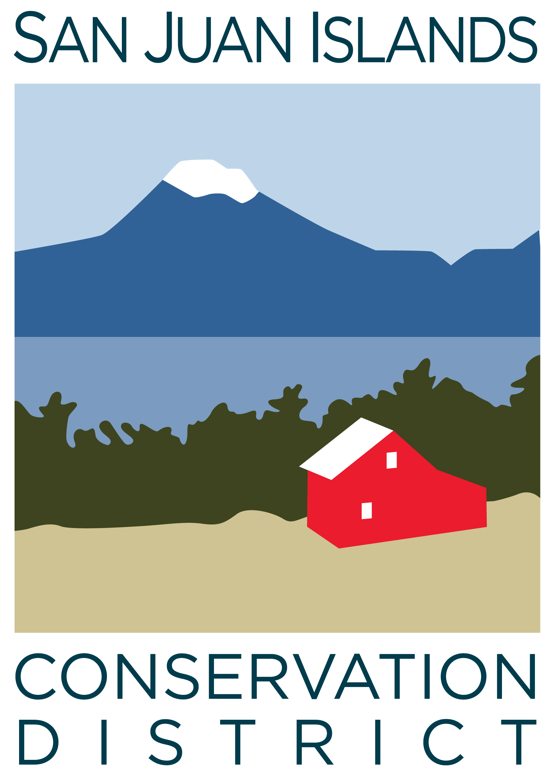
San Juan Islands Conservation District
BOARD OF SUPERVISORS
REGULAR MEETING MINUTES

Date: | September 30, 2024
Time: | 9:00am – 11:00am
Place: | 915 Spring St. Friday Harbor, WA 98250  And online via Zoom
Attending Supervisors: | Lynn Bahrych, David Bill, Claire Crawbuck, Vicki Heater, Carson Sprenger
Partners: | Jean Fike, WSCC Puget Sound Regional Manager, Kathy Smith, NRCS; Alan Chapman, WACD NW Region Representative
Staff: | Paul Andersson, Tony Fyrqvist
Public: | Roger Bairstow

 | Welcome and Introductions
1 | Agenda Approval
 | Action Item: Vicki made a motion to approve the agenda, Lynn seconded, and the motion passed.
2 | August 2024 Regular Meeting Minutes Approval
 | Action Item: Vicki made a motion to approve the Minutes from the 8/23/24 Regular Meeting. Lynn provided the second and the motion passed.
3 | Financial Report – August 2024 Financials
Action Item: Motion was made by Lynn and seconded by Claire to approve the August 2024 financial documents, including:
- Financial Summary
- Balance Sheet
- Statement of Revenues and Expenses
- Credit Card Details
- Bank Reconciliation
- Adjusting Journal Entries
- Payroll
Discussion consisted of review of the Financial Summary report. The Financial Manager made an additional comment regarding total District revenue growth rates between fiscal years:
- 8.50% growth between FYE 6/30/22 and FYE 6/30/23
- 28.64% growth between FYE 6/30/23 FYE 6/30/24 – this was mostly attributable to growth in ICC income and WSCC Forest Health funding.
- There was conversation about structuring the operation of the newly acquired building as a separate program with associated costs and revenue streams.
- The motion passed.
Discussion:
- Discussed Grant Pipeline report showing close to $2 million in proposed new grant applications.
4 | Old Business
Conservation Campus Grand Opening Discussion:
- Conservation Campus grand opening and ribbon cutting event has been scheduled for 11/14/24 from 3:00pm – 6:00pm - with ribbon cutting at 5:00pm.
- Discussed fundraising for refreshments for the event while complying with RCW 43.03.050 governing expenses for light refreshments.
Board Chair Resignation Discussion:
- Carson Sprenger reported to the board reasons for resigning from the Board, which were outlined in his letter of 7/18/24, and which mainly included the requirement for additional time needed to spend with family and business. He cautioned the district to establish a contingency plan for contraction and to slow its growth trajectory, as public finding might decline in the future.
5 | New Business
New Board Member Appointment, Action Item:
- Lynn made a motion to appoint Roger Bairstow to fill the elected position on the Board vacated by Carson Sprenger for the remaining term. A discussion covered the district’s public process to seek interested applicants and the positive attributes that Roger brings to the CD including his familiarity with District work, being a farmer, a property owner on Orcas Island and having an extensive background in agriculture and business management. The motion was seconded by David and passed.
Board Position Appointments, Action Item:
- Claire made a motion to formalize David and Lynn as Co-Chairs. The motion was seconded by Vicki and passed.
- David made a motion, seconded by Vicki, to name Claire as a Vice Chair. The discussion covered possibility of becoming a Chair in the future and having to cover meetings in the absence of the Co-Chairs. The motion passed.
WSCC Funding Approvals, Action Item:
- Roger made a motion to approve new WSCC Sustainable Farms and Fields funding: $27,500 for habitat technical assistance and $3,750 for No-Till Drill technical assistance. David provided the second and the motion was approved.
Communications Easement, Discussion Item:
- The District received a Communications System Easement request from OPALCO to install communications cables and equipment through District property to neighboring building. The primary reason for the request was to save trenching costs to 30 ft from approximately 260 ft. District concerns include the open-ended wording of the easement as to what can be placed on the easement, potential liability, disturbance of vegetation and grounds, and a ‘gift of public funds’ conflict if the district incurs costs that are not reimbursed. The easement was not approved at this time and the District will conduct further research with our insurance provider Enduris.
WSIPP CD Elections Questionnaire, Discussion Item:
- The CD Elections Questionnaire responses drafted by staff were reviewed and will be submitted to Washington State Institute for Public Policy. Discussion mentioned the pitfalls of trying to use legislation as a means to affect election outcomes such as higher voter turnout and diversity, as opposed to improving awareness through communications, education and other means.
6 | Staff and Program Reports
Discussion:
- This month’s Staff and Program Reports included many photos showing more insight into the work described.
- A new landowner satisfaction survey was provided for review. One point of feedback was whether ARC GIS Survey123 is the appropriate platform for obtaining this feedback as it often acquires geographic location of the survey-taker, which may be inappropriate.
- Program funding impacts were discussed relative to the November election ballot initiative to repeal the Climate Commitment Act (as Initiative 2117). The Climate Control Act has been a large source of the forestry and salmon recovery funding and a repeal would have a substantial negative financial impact on the District.
7 | Recent and Upcoming Trainings/Webinars/Events
Discussion:
- Farm Tours – San Juan Farm Tours were on 9/27-29, Orcas will be on 10/4-6; and Lopez on 10/11-13. Lopez Farm Tours has a record 15 farm hosts. Discussion included increasing identification of CD involvement in Farm Tours via placards and signage at farm and project sites.
8 | Partner Reports
Alan Chapman:
- WACD has collected all past due dues payments from all conservation districts.
- Finance committee has invested excess capital funds into a Local Government Investment Pool for a 2% higher return than provided by alternate investments
- Plant Materials Center is behind in orders.
- NW Area meeting is hosted by Jefferson County CD on 10/24
- The 2024 WACD Annual Meeting will take place on 12/2-4 in Spokane.
Jean Fike:
- Hilary Aten has been hired by Commission as a Farmland Preservation Coordinator.
- Commission’s Conservation Technical Assistance budget request has been included in a list of requests that advance the Governor’s salmon recovery goals.
Kathy Smith:
- Almost $300,000 in contracts was extended to San Juan County during Fiscal Year ending 6/30/24,
- EQIP application deadline for applications is 10/22/24.
- CSP Program deadline for applications is 1/17/25.
- Met with the San Juan Islands Preservation Trust encouraging participation in NRCS forestry programs.
9 | Executive Session – Review of Public employee performance
 | In accordance with RCW 42.30.110 the regular meeting was adjourned at 10:30am for an Executive Session to review the performance of a public employee. The regular meeting was resumed at 10:50am.
10 | Public Comments
 | None.
11 | Adjournment 11:00am
Next Meeting: |  | Regular Meeting - Friday, October 25, 2024, from 9:00am to 11:00am

