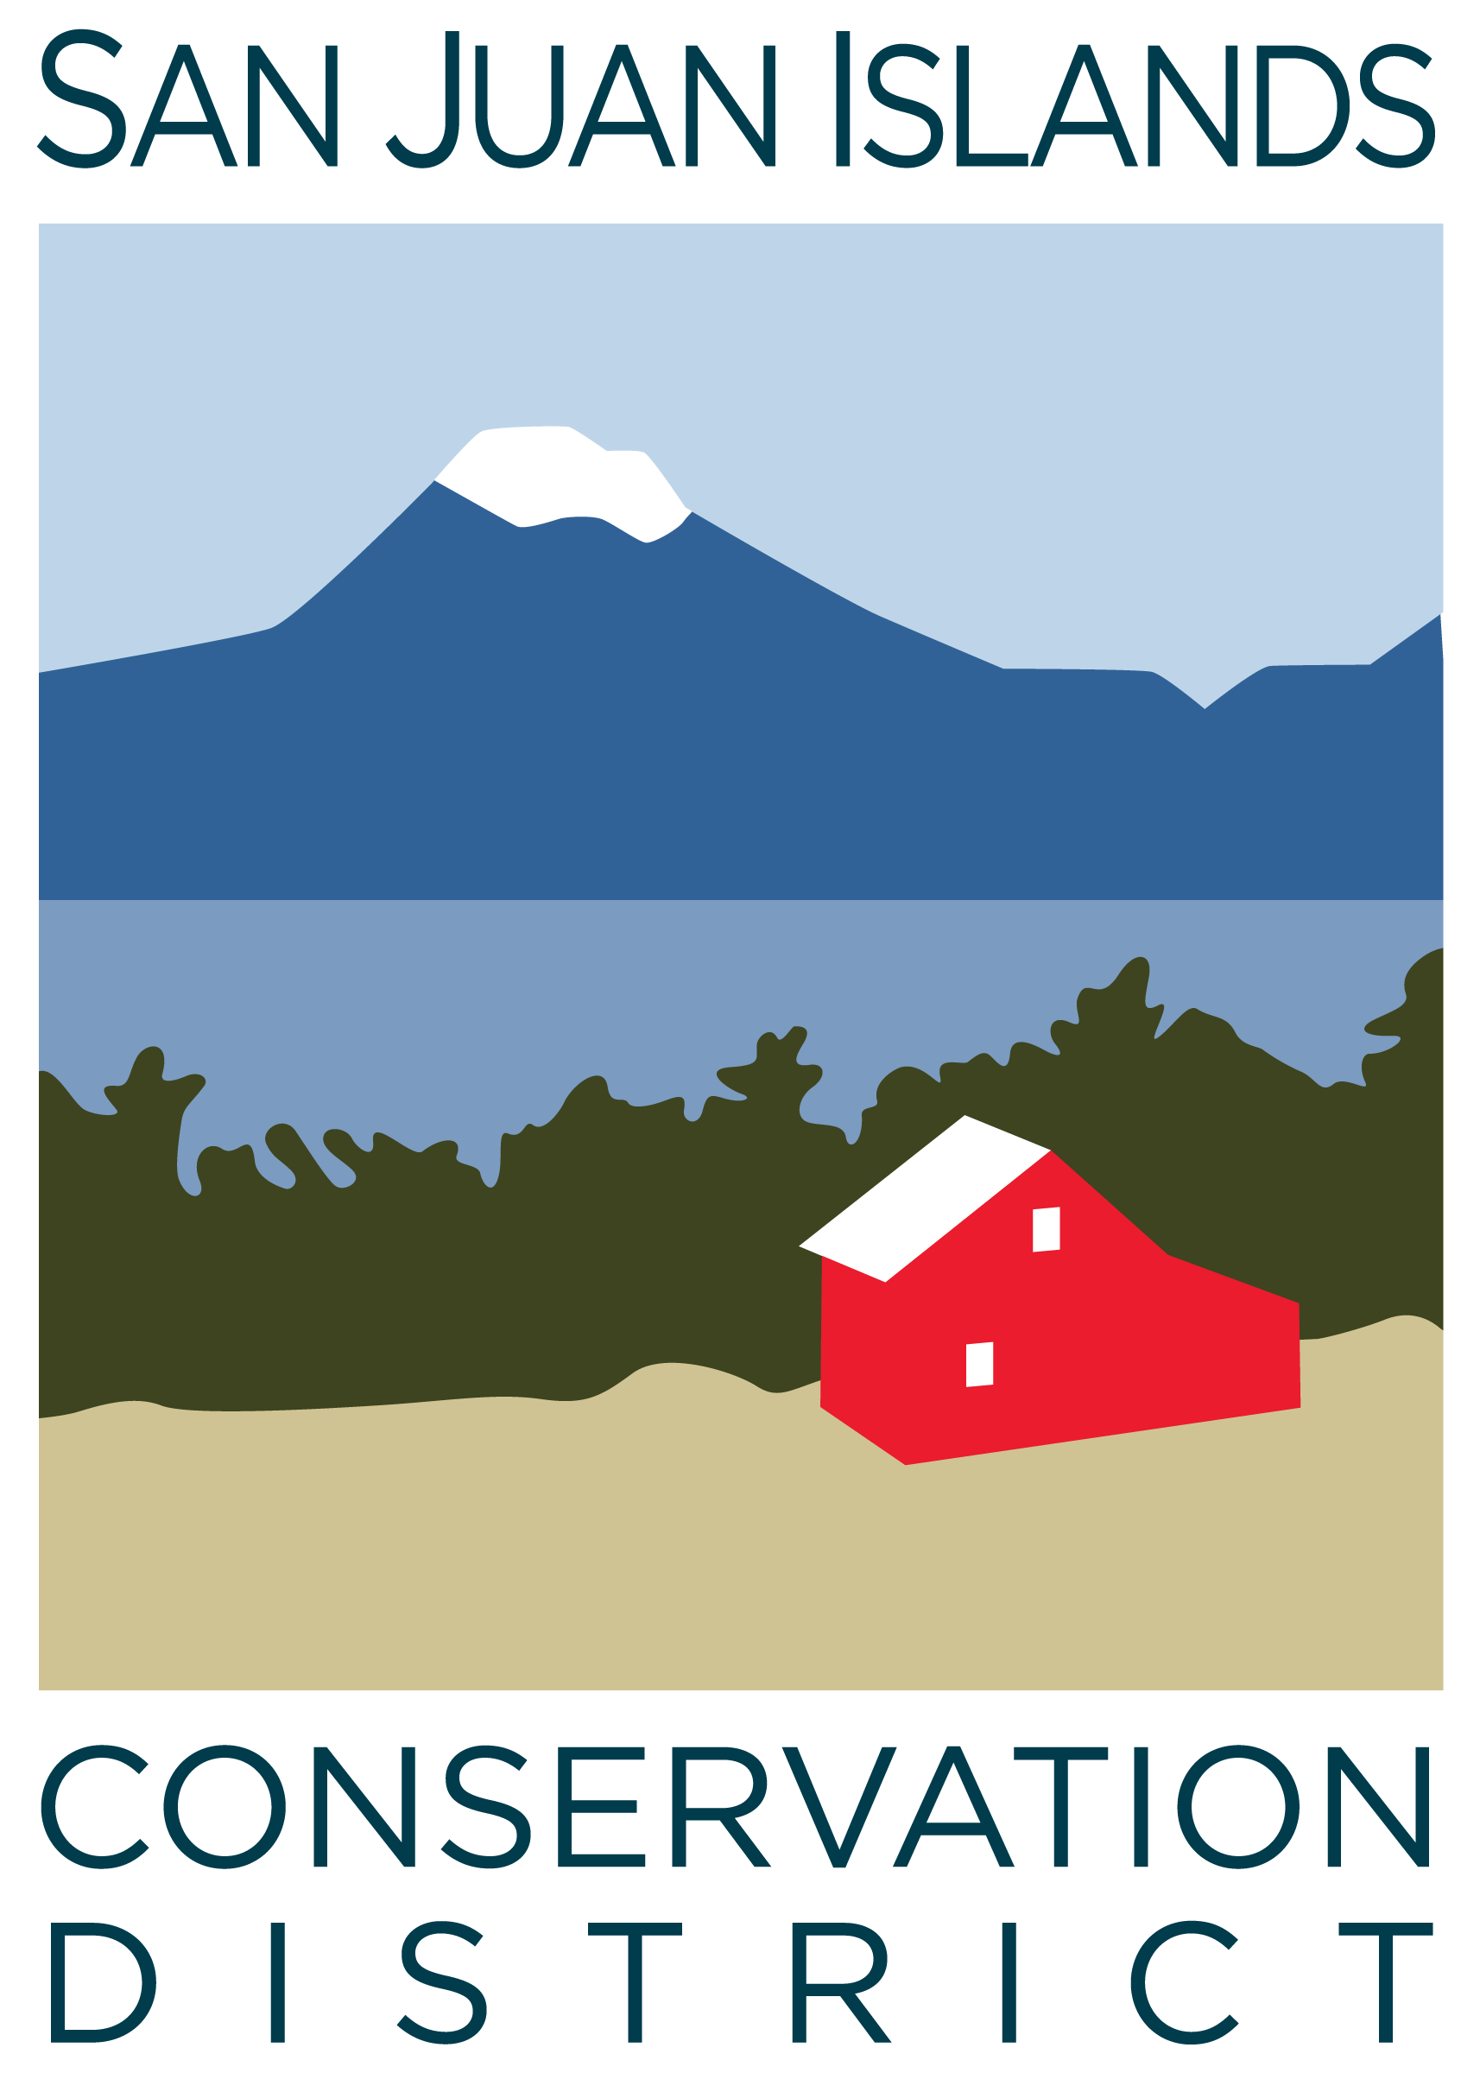
San Juan Islands Conservation District
BOARD OF SUPERVISORS
REGULAR MEETING MINUTES

Date: | February 23, 2024
Time: | 8:30am – 10:30am
Place: | 530 Guard Street, Friday Harbor, WA 98250  And online via Zoom
Attending Supervisors: | Carson Sprenger, David Bill, Vicki Heater, Lynn Bahrych, Claire Crawbuck
Attending Associates: | Jim Skoog
Absent: | Paul Andersson
Partners: | Jean Fike, WSCC Puget Sound Regional Manager, NRCS; Alan Chapman, WACD
Staff: | Tony Fyrqvist, Cathi Winings
Public:

1 | Agenda Approval
 | Action Item: Motion to approve the Agenda was made by Claire, seconded by David. Action item was added under 5. New Business to include a motion to approve Community Engagement Funding Plan (CEP) award for $18,000 from the Conservation Commission. The motion passed.
2 | January 2024 Regular Meeting Minutes Approval
 | Action Item: Motion to approve the January 2024 meeting minutes was made by David and seconded by Claire. The motion passed.
3 | Financial Officers Report – December Financials
Action Item: Motion was made by David and seconded by Lynn to approve the January 2024 financial documents, including:
- Balance Sheet
- Statement of Revenues and Expenses
- Credit Card Details
- Bank Reconciliation
- Adjusting Journal Entries
- Payroll
Discussion included:
- Financial Manager’s comments - which were also provided in the SJICD Financial Summary - highlighting the projected reduction in the operating account balance during Spring 2024. However, at this moment we do not project a need to access reserve funds.
The motion passed.

Topic : Pipeline Report
- Brief discussion covering ongoing grant applications.
4 | Old Business
Discussion Item - Property Acquisition:
- The Purchase and Sale Agreement for District property acquisition specifies a closing date of “no later than March 12, 2024” which will have to be extended as USDA has communicated their inability to fund the loan by that date.
- As the lease on current premises specifies a 60-day notice to vacate it was proposed that April 1 would be a logistically suitable date to provide the notice to the current landlord.
- The HVAC system addressed in the inspection report has been deemed to be functional and did not result in any changes in the purchase price.
- Currently the District is not planning on making a down payment in addition to the $10,000 earnest money requirement.
- The sublease form has not been seen by the Board yet. The only initially identified sublessor is San Juan County Emergency Management.
 | Discussion Item - 2024 Elections: District has published election notices and candidates have fulfilled their filing deadlines. There was a discussion about participation, regulations, and cost of participation in a general election. Expanded outreach and social media presence in the election process was encouraged. Generally, the system is deemed to be efficient and most small districts operate similarly to ours.
 | Discussion Item - Legislative Updates: The $10 million request for Conservation Technical Assistance needed by the Districts to fulfill their missions was not approved, however, there is still hope that the $3.5 million on the Governor’s Budget might be passed.
 | Action item: David made a motion to approve SJICD Procurement Policy and was seconded by Claire. The motion passed.
5 | New Business
 | Action Item: David made a motion to approve Resolution 2024-002 authorizing facility purchase and signing authority of Executive Director. He was seconded by Claire. The motion passed.
 | Action item: David made a motion to approve WSCC Community Engagement Plan (CEP) funding 24-03-CEP for $18,000 and was seconded by Claire. The motion passed.
Discussion Item – Spring Retreat:
Location suggestions:
- New facility at 915 Spring St. in Friday Harbor.
- Midnight’s Farm on Lopez Island.
Possible facilitators:
- Formal – last year Jean Fike facilitated the retreat.
- John Howell.
- Lynn Hobbs.
- Or no facilitator resulting in a more casual, less rigid, format.
Dates:
- Possibly combining the retreat with a Friday Board Meeting Date.
- Picking another date suitable for most Board and Staff members.
Theme:
- Engage the real estate community. Work on an informational flyer of services provided to landowners specifically targeting new buyers.
 | Action item: David made a motion proposing April 12th, 2024 as the tentative date for the Spring Retreat conditional on Supervisor and staff availability. Claire seconded and the motion passed.
6 | Staff and Program Reports
Cathi Winings reviewed the “Staff and Program Reports”. Particular emphasis was placed on:
- The high community interest in Agriculture and Forestry Cost Share programs.
- Staff attendance at the forestry inter-agency collaboration meeting with DNR, WSU-Extension, NRCS and other Conservation Districts, the conversation covered establishing connections with realtors and informational packages to new landowners.
- The Commissioner of Public Lands, Hilary Franz, is tentatively scheduling a May 8th visit to the San Juans to roll out the Wildfire Preparedness Month at a fire station on Orcas Island with visits to Decatur and other DNR-funded project areas in San Juan County. Preference for visiting ferry serviced areas was stated.
7 | Subcommittees
Topic: Forest Health Collaborative Subcommittee
A consultant based in Alaska, with over 20 years of oil spill response experience, has been identified to execute an update to the Community Wildfire Protection Plan. The response from the County to the consultant has been positive due to work within a comparative ecology.
8 | Upcoming Trainings/Webinars/Events
Topic : WADE Conference June 10-12
- Attendance at the Conference was encouraged by past attendees and the event was described as fun, stimulating and engaging while providing learning and networking opportunities.
- Alternate lodging such as an Air B&B could provide more comfortable accommodation.
9 | Partner Reports
Alan Chapman:
- Stated that that the Plant Materials Center (PMC) is currently overstocked and encouraged CDs to take a full advantage of what is available.
Jean Fike:
- Levi Keesecker will be leading the Commission’s new Science Hub – more information will be coming.
- Kate Delavan is the acting Policy Director – along with remaining as Director of the Office of Farmland Protection.
10 | Public Comments
 | None.
11 | Idea Pot
Topic : Climate Sustainability Committee
- Discussed the need to engage the public and CD role within the process.
- The overall goal is to produce recommendations and documentation to San Juan County to affect policy and regulations. Regulations should not prohibit actions promoting climate sustainability.
- CD should weigh in particularly on water and forestry resources.
12 | Adjournment 10:25am
Next Meeting: |  | Friday, March 22, 2024 from 8:30am to 10:30am

