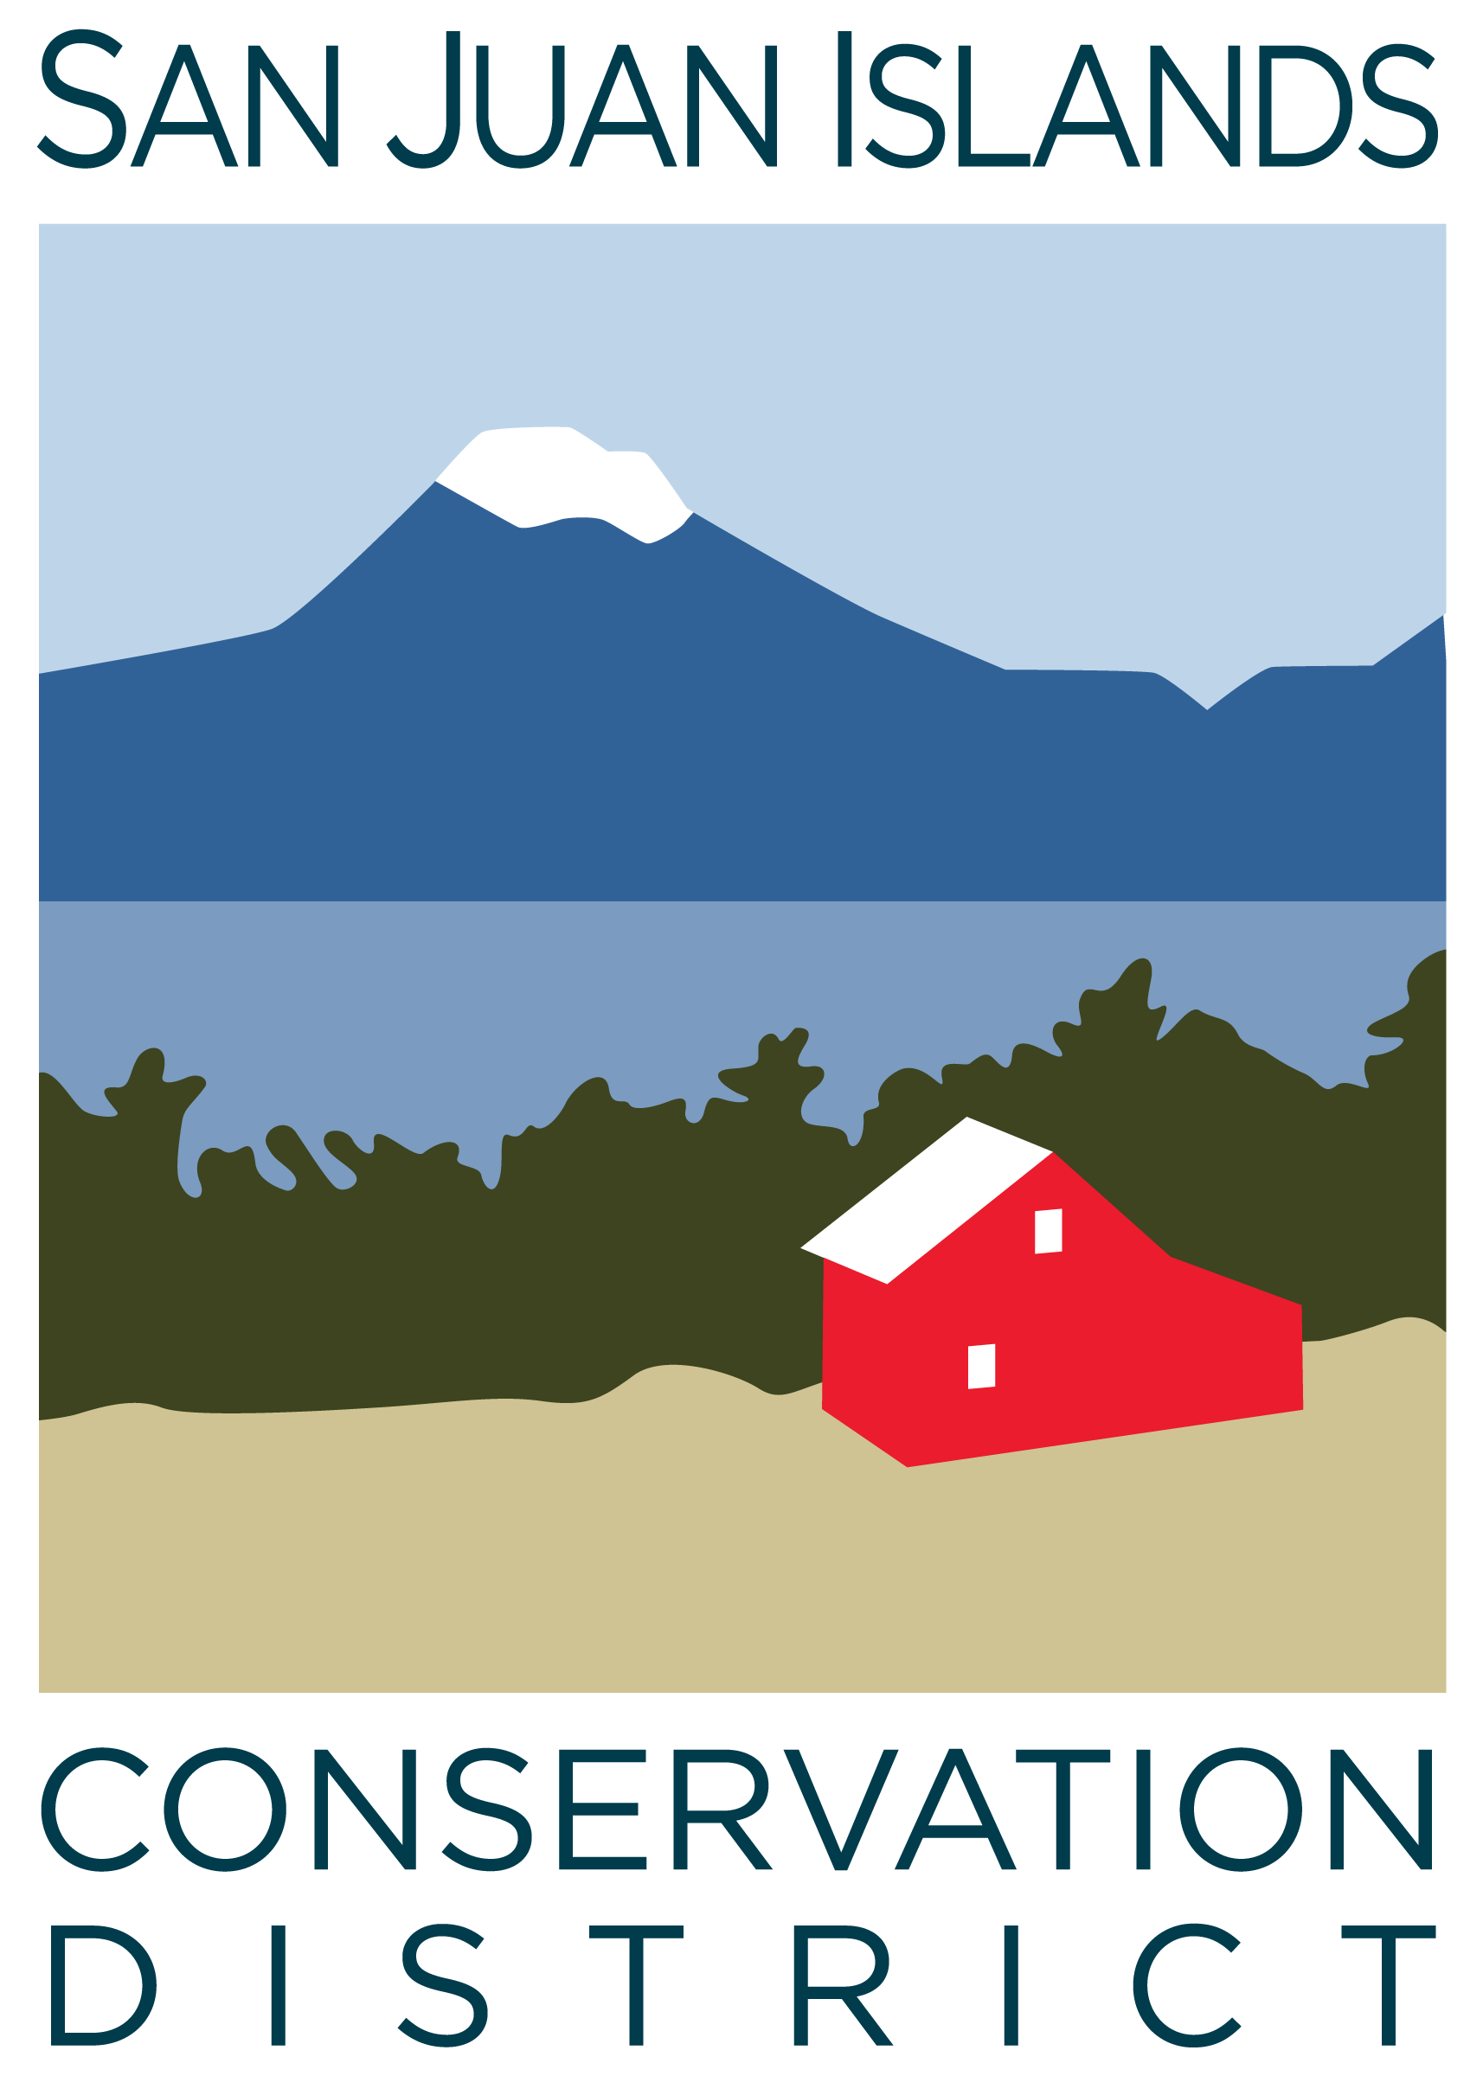
San Juan Islands Conservation District
BOARD OF SUPERVISORS
REGULAR MEETING MINUTES

Date: | October 27, 2023
Time: | 8:30am – 10:30am
Place: | 530 Guard Street, Friday Harbor, WA 98250  And online via Zoom
Attending Supervisors: | Carson Sprenger, David Bill, Vicki Heater, Lynn Bahrych, Claire Crawbuck
Attending Associates:
Absent: | David Bill, Supervisor; Jim Skoog, Associate
Partners: | Kathy Smith, NRCS
Employees: | Paul Andersson, Tony Fyrqvist, Julie Curtis, Mike Rosekrans
Public: | None

1 | Agenda Approval
 | Action Item: Agenda was approved by consensus without any changes.
2 | September 2023 Regular Meeting Minutes Approval
Action Item: Motion to approve the September 2023 meeting minutes was made by Lynn, seconded by Vicki.
The motion passed without discussion.
3 | Financial Officers Report – September Financials
Action Item: Motion made by Vicki and seconded by Claire to approve September 2023 financial documents, including:
- Balance Sheet
- Statement of Revenues and Expenses
- Credit Card Details
- Bank Reconciliation
- Adjusting Journal Entries
- Payroll
Discussion included Financial Manager’s comments provided in the SJICD Financial Summary 9/30/23 document.
The motion passed.
4 | Old Business
Topic: Property acquisition of 915 Spring St. Friday Harbor, WA 98250
Discussion of next steps in the property acquisition process, including:
- SJC Council adoption of a county resolution approving direct sale of the facility to SJICD, which will also require a public hearing.
- Application/approval pending with USDA Rural Development loan program, the budget for which is currently tied up with Congressional appropriations.
- Benefits of holding a fundraiser from the premises once the District has moved in.
- Logistics and process around establishment of a “Conservation Campus” with several potential partner agencies subleasing space.
Topic: WACD Resolution on Use of Charcoal/Biochar in Livestock Feed
Discussion of status of this resolution after SJICD board adoption and presentation to WACD NW Area:
- The resolution was approved by the WACD Northwest Area and will be presented in the 11/27/23 Annual Business Meeting which will be attended by the District Manager.
- Agreement of support for a resolution regarding lifting the state cap on assessments for districts, based on population.
Topic: SJICD Board Self-Review
This conversation will continue in the next Board meeting after Board Member answers to questionnaire have been compiled.
David was nominated to compile the information.
Topic: Policy Review – Procurement, Boat Use, Public Records
Action Item: Motion to approve SJICD Boat Use Policy made by Vicki and seconded by Claire.
Discussion including a change to VI 1. C. “Origin and destination” to state “Origin, route and destination”.
The motion passed as amended.

Discussion of Procurement Policy included:
- Reminder that Procurement policy was developed using MRSC guidelines.
- Discussion about guard rails, contracting thresholds and other processes within the policy.
- Brief conversation about level of approval authority between District Management and Board of Supervisors.
- Recommendation to engage legal counsel to review contracts and policy
- Agreement that conversation will continue within the Policy Subcommittee chaired by Lynn.
- No major contracts are pending at the moment.
Discussion of Public Records Policy included:
- Staff review of Public Records Policy this month showed some opportunities for improvement but nothing seriously lacking. Recommended edits will be presented to the Policy Subcommittee
5 | New Business
Action Item: Motion to change the next board meeting date to 12/1/23 was made by Vicki and seconded by Claire.
The motion passed.
Action Item: Motion to increase the amount at which a Purchase Order is required for expenditures from $500 to $2,000 was made by Lynn and seconded by Vicki.
The motion passed.
6 | Executive Session – Review of public employee performance
 | Executive session was held starting 9:40am in accordance with RCW 42.30.110 (g) To review the performance of a public employee.
 | Executive session was adjourned at 9:55am.
 | Regular meeting resumed at 9:55am.
Action Item: Motion made by Vicki and seconded by Claire to:
- Support a compensation increase for the District Manager based on COLA rates and high performance, and in accordance with the SJICD wage table and comparable rates within other local agencies.
- Increase vacation time for the District Manager by two weeks per year.
- Change the title of the District Manager to Executive Director.
The motion passed.
Action Item: Motion made by Vicki and seconded by Lynn to:
- Appropriate funding, if available, for a part- or full-time operations or administrative or programs assistant to support the Executive Director in carrying out all district functions.
The motion passed.
7 | Staff and Program Reports
Topic: Youth Conservation Corps: 2023 Review
Youth Conservation Corps Program Coordinators Julie Curtis and Mike Rosekrans provided a presentation including:
- Personal Introductions
- YCC Summer 2023 by the Numbers
- Project Highlights
- Crew Member Feedback
- Parent Feedback
- New and Potential Partners for YCC
- YCC Funding
8 | Subcommittees
Topic: Forest Health Collaborative Subcommittee
Discussion stating that the Subcommittee met on 10/26 and discussed District engagement with local fire districts, equipment purchases, training and next steps for a CWPP update. Meeting notes were shared with board members via email.
9 | Upcoming Trainings/Webinars/Events
Topic: Recap of upcoming events and debrief of recent events held
Discussion that the WWU/ICC Fundraiser on 10/14/23 was attended by 14 participants.
10 | Partner Reports
Topic: NRCS Updates
Discussion led by Kathy Smith from NRCS stating that they have received 22 applications from San Juan County for the Environmental Quality Incentives Program (EQIP) and Conservation Stewardship Program (CSP). 2/3 of the applications are for forestry and 1/3 for agriculture.
11 | Public Comments
 | None.
12 | Idea Pot
Topic: 32 hour workweek adopted by San Juan County
Discussion about if or how this could function and be productive for SJICD.
Topic: Board meeting minutes
Discussion about transitioning to “Action minutes” that reflect more of what is done and decided at meetings (actions taken) instead of reporting what is said.
Action Item: Motion for the District to adopt “Action Minutes” effective immediately was made by Lynn and seconded by Vicki.
The discussion covered the value of former narrative minutes providing more detail as contrasted with the efficiency and more timely production of the “Action Minutes”.
The motion was approved.
13 | Adjournment 10:45am

Next Meeting: | Friday, December 1, 2023 from 8:30am to 10:30am.

