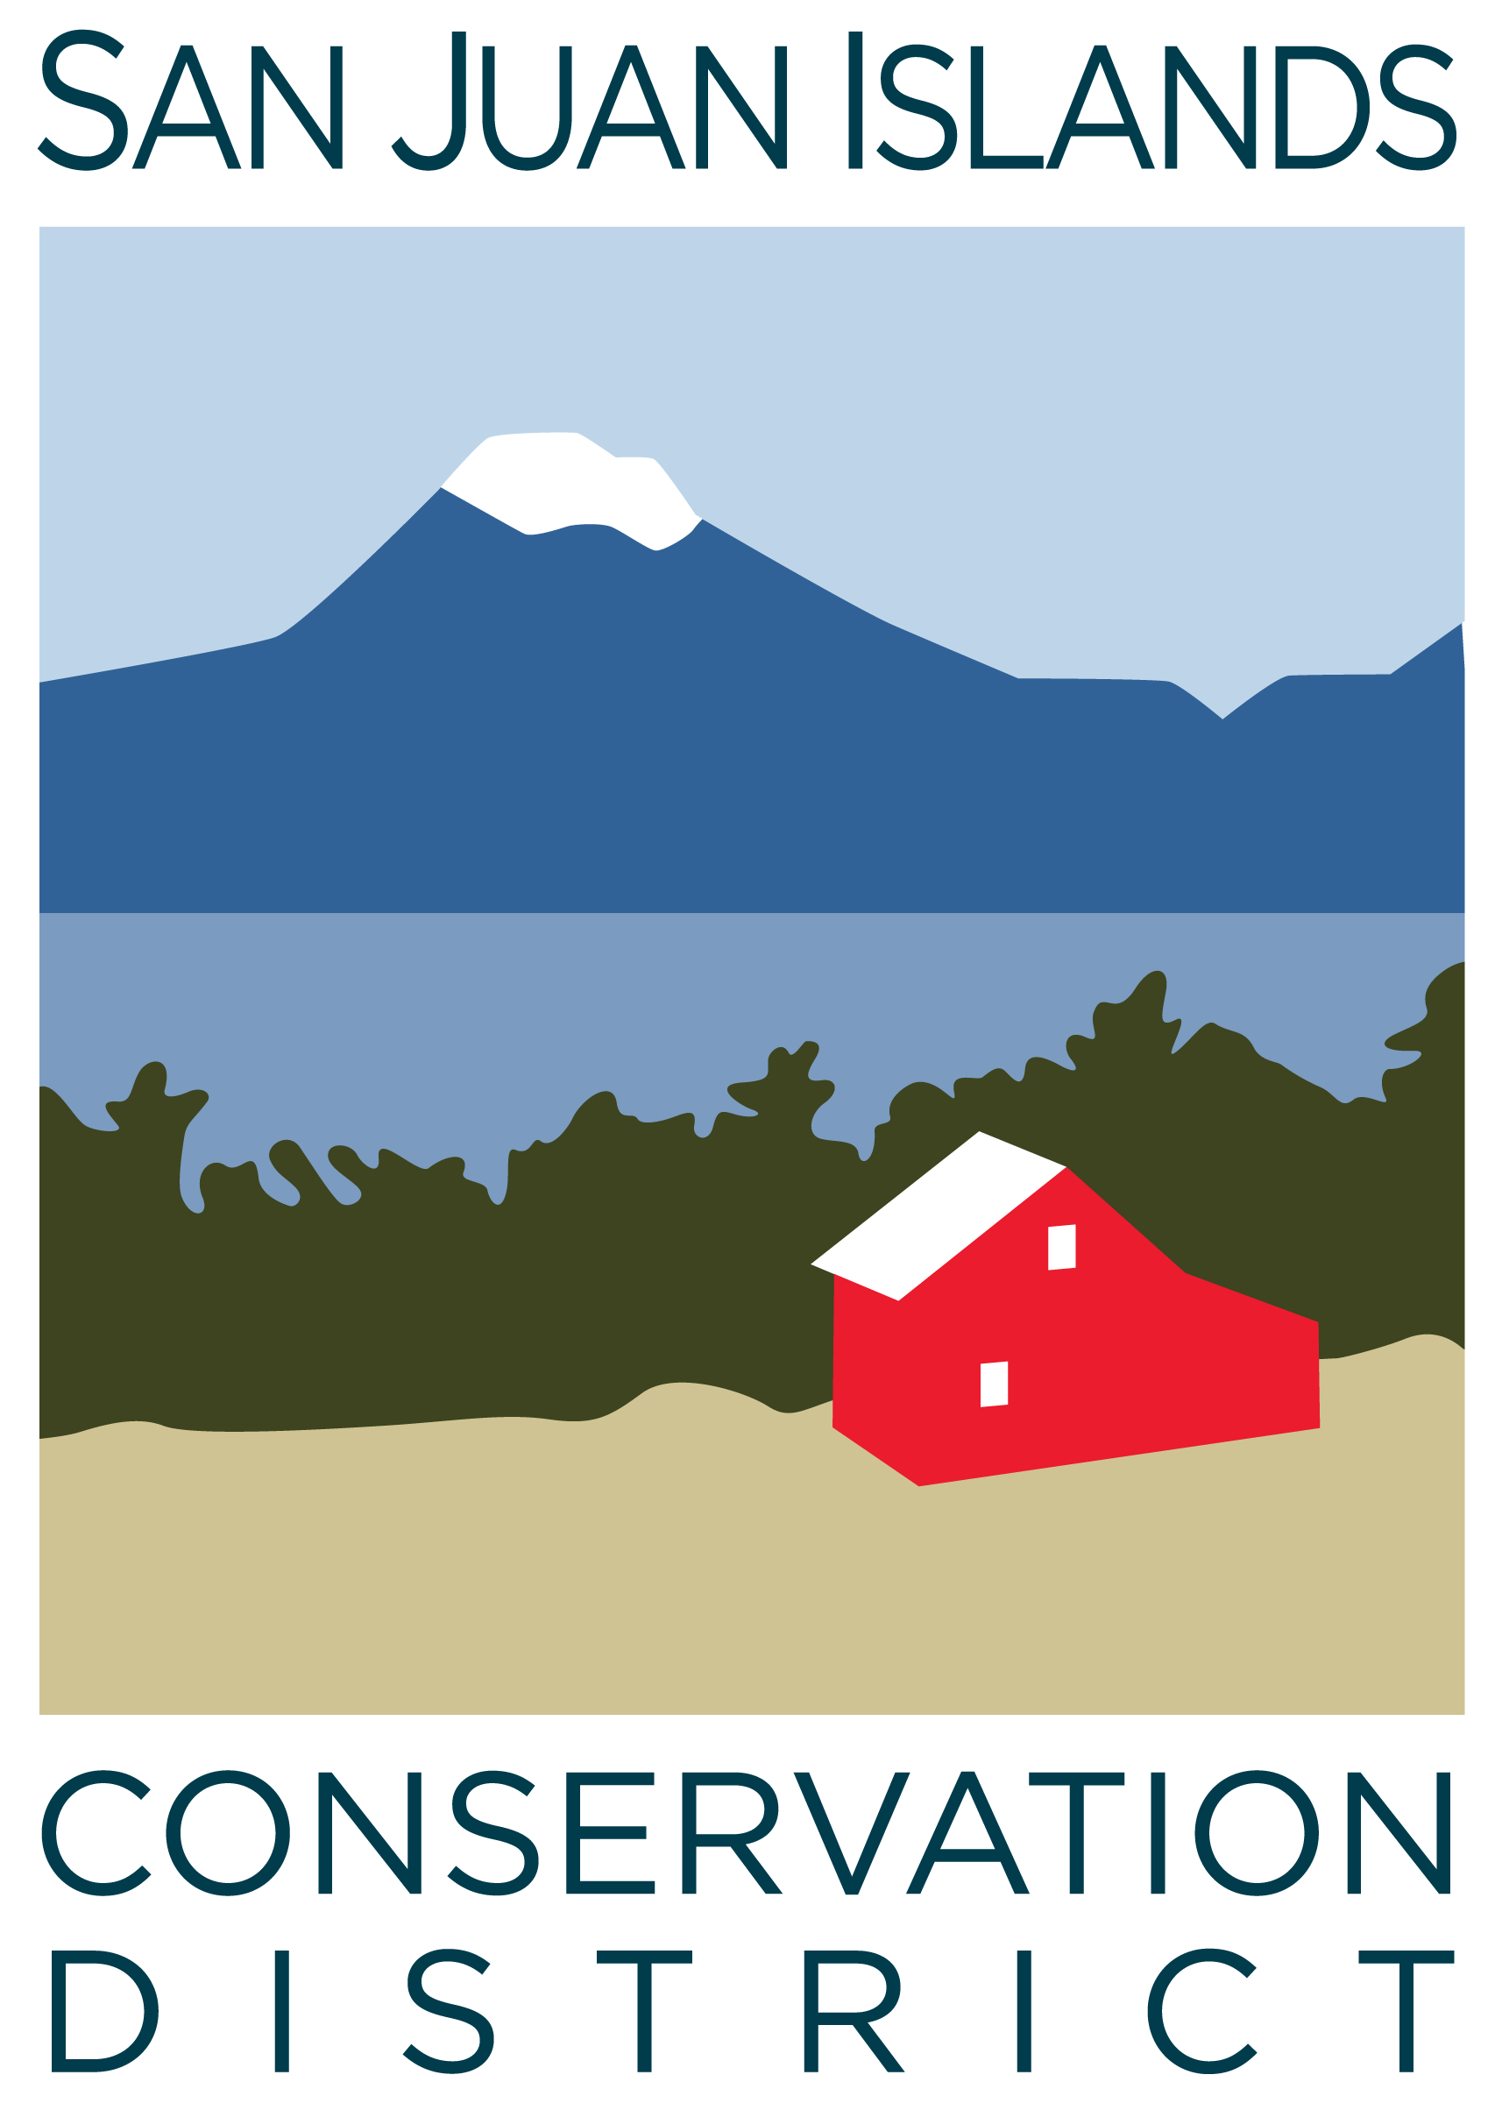
San Juan Islands Conservation District
BOARD OF SUPERVISORS
REGULAR MEETING MINUTES

Date: | August 23, 2024
Time: | 9:00am – 11:00am
Place: | 915 Spring St. Friday Harbor, WA 98250  And online via Zoom
Attending Supervisors: | David Bill, Vicki Heater, Lynn Bahrych
Attending Associates:
Absent: | Carson Sprenger, Claire Crawbuck, Jim Skoog
Partners: | Kathy Smith, NRCS; Alan Chapman, WACD NW Region Representative
Staff: | Paul Andersson, Tony Fyrqvist
Public: | Roger Bairstow

 | Welcome and Introductions
 | David opened the meeting as Carson was absent.
1 | Agenda Approval
 | Action Item: Vicki made a motion to approve the meeting minutes and was seconded by Lynn. The Agenda was amended to include approval of a credit card limit increase for the Executive Director from $1,000 to $2,000 under 4. New business. The amended agenda was approved.
2 | July 2024 Regular Meeting Minutes Approval
 | Action Item: Lynn made a motion to approve the Minutes from the 7/26/24 Regular Meeting. Vicki provided the second and the motion passed.
3 | Financial Report – July 2024 Financials
Action Item: Motion was made by Lynn and seconded by Vicki to approve the July 2024 financial documents, including:
- Financial Summary
- Balance Sheet
- Statement of Revenues and Expenses
- Credit Card Details
- Bank Reconciliation
- Adjusting Journal Entries
- Payroll
Discussion consisted of the review of the Financial Summary report, as well as the pros and cons between paying down the building loan and retaining (and growing) a reserve account. The motion passed.
4 | New Business
 | Action Item: Vicki made a motion increase the card limit with Banner Bank for Paul Andersson, Executive Director, from $1,000 to $2,000. The motion was seconded by Lynn and passed.
5 | Old Business
Discussion:
- Conservation Campus Open House and ribbon cutting event was suggested for the end of Oct-24 to Early Nov-24 (after San Juan Island Farm Tours).
- New board supervisor search article will be posted in local papers and online and applications will be evaluated by Sept 20th.
- The conversation about co-chairs will be continued in the next board meeting.
6 | Staff and Program Reports
Discussion:
- No Program Report document was provided this month – activities from last month are still largely in process.
- A new ICC Assistant Supervisor was hired in August.
7 | Subcommittees
Discussion:
- Forest Health Subcommittee is discontinued.
- YCC Fundraising Subcommittee is developing a promotional video for fundraising.
8 | Recent and Upcoming Trainings/Webinars/Events
Discussion:
- Preparations for Farm Tours continue with advertising materials - discussed increasing District’s visibility with the program.
- 25 Congressional and partner agency staffers toured the Conservation Campus on 8/20/24.
- Governor Inslee’s staffers and San Juan County Manager will tour the building on 8/23/24.
- Governor Inslee will conduct a meeting at the facility on 8/24/24.
- NCRS Workshop is scheduled at Skagit Valley College on 9/10/24.
9 | Partner Reports
Alan Chapman:
- District Area Meeting will be in Port Townsend on 10/24/24.
- Annual Conference will be in Spokane last weekend in November – Early December 2024.
Kathy Smith:
- EQIP application deadline for applications is 10/22/24.
- CSP Program deadline for applications is 1/25/25.
 | Public Comments
 | Roger Bairstow discussed his participation in the EQIP program and gratitude for assistance he has received from SJICD planners including Pauline Chiquet.
11 | Idea Pot
Discussion:
- Presenting testimonials from landowners participating on various programs on the District website.
- Development of satisfaction surveys regarding Planner technical assistance, site visits, forest and farm plans.
- 9/9/24 is the 77th birthday of the District. Idea to host a small gathering of board and staff with cake.
12 | Adjournment 11:00am
Next Meeting: |  | Regular Meeting - Friday, September 27, 2024, from 9:00am to 11:00am

